

# **ACYCLE**

version 2.0

Time-series analysis software for paleoclimate research and education

**User’s Guide**

**Mingsong Li**

[www.mingsongli.com/*Acycle*](http://www.mingsongli.com/acycle)

[https://github.com/mingsongli/*Acycle*](https://github.com/mingsongli/acycle)

[https://github.com/mingsongli/*Acycle*/wiki](https://github.com/mingsongli/acycle/wiki)

Pennsylvania State University, State College, USA

Feb 20, 2020

Contents

ACYCLE - 1 -

What they say - 4 -

1. Copyright - 6 -

2. References - 7 -

3. Software Specifications - 9 -

**3.1 System Requirements** - 9 -

**3.2 Downloading the Acycle software** - 10 -

**3.3 MatLab version** - 11 -

**3.3.1 Installation** - 11 -

**3.3.2 Startup** - 11 -

**3.4 Mac version** - 12 -

**3.4.1 Introduction** - 12 -

**3.4.2 AcycleX.X-Mac-green** - 12 -

**3.4.3 AcycleX.X-Mac-Installer** - 15 -

**3.5 Windows version** - 19 -

**3.5.1 Introduction** - 19 -

**3.5.2 AcycleX.X-Win-Installer** - 19 -

**3.5.3 AcycleX.X-Win-green** - 19 -

**3.6 Data Requirements** - 21 -

4. *Acycle* graphical user interface (GUI) - 22 -

**4.1 Functions and GUI** - 22 -

**4.2 File** - 23 -

**4.3 Edit** - 23 -

**4.4 Plot** - 24 -

**4.5 Basic Series** - 26 -

**Insolation** - 26 -

**Astronomical Solution** - 27 -

**Signal/Noise Generator** - 28 -

**LR04 Stack** - 30 -

**Examples** - 30 -

**4.6 Math** - 35 -

**Sort/Unique/Delete-empty** - 35 -

**Interpolation** - 35 -

**Select Parts** - 35 -

**Merge Series** - 35 -

**Add Gaps** - 36 -

**Remove Parts** - 36 -

**Remove Peaks** - 36 -

**Clipping** - 36 -

**Smoothing:** - 36 -

**Moving Average** - 36 -

**Moving Median** - 37 -

**Bootstrap** - 37 -

**Changepoint** - 37 -

**Standardize** - 38 -

**Principal Component** - 38 -

**Log-transform** - 38 -

**Derivative** - 38 -

**Simple Function** - 38 -

**Utilities** - 39 -

**Find max/min** - 39 -

**Image:** - 39 -

**Show Image** - 39 -

**RGB to Grayscale** - 39 -

**Image Profile** - 39 -

**Plot Digitizer** - 39 -

**4.7 Time series** - 41 -

**Detrending | Curve Fitting** - 41 -

**Prewhitening - First Difference** - 42 -

**Spectral Analysis** - 42 -

**Evolutionary Spectral Analysis** - 44 -

**Wavelet transform** - 46 -

**Filtering** - 46 -

**Build Age Model** - 47 -

**Age Scale** - 48 -

**Sedimentation Rate to Age Model** - 48 -

**Power Decomposition Analysis** - 49 -

**Sedimentary Noise Model** - 49 -

**Correlation Coefficient (COCO/eCOCO)** - 50 -

**TimeOpt** - 55 -

**eTimeOpt** - 56 -

**Spectral Moments** - 58 -

**4.8 Help** - 59 -

**What’s New** - 60 -

**Manuals** - 60 -

**Find Updates** - 60 -

**Copyright** - 60 -

**Contact** - 60 -

**4.9 Mini-robot** - 61 -

5. DYNOT model Description - 62 -

**5.1 Data format** - 62 -

**5.2 Startup** - 62 -

**5.3 Settings** - 63 -

**5.4. Running the DYNOT model** - 66 -

**5.5. Output Files** - 67 -

6. Case Studies - 68 -

**Typical procedures in cyclostratigraphy** - 68 -

**Example #1: Insolation** - 70 -

**Step 1: Load data** - 70 -

**Step 2: Data pre-processing** - 71 -

**Step 3: Detrending** - 71 -

**Step 4: Power Spectral Analysis** - 72 -

**Step 4: Evolutionary Spectral Analysis** - 73 -

**Example #2: La2004 astronomical solution (ETP)** - 75 -

**Step 1: Load data** - 75 -

**Step 2: Data pre-processing** - 76 -

**Step 3: Detrending** - 76 -

**Step 4: Power Spectral Analysis** - 77 -

**Step 5: Evolutionary Spectral Analysis** - 78 -

**Step 6: Wavelet transform** - 79 -

**Example #3: Carnian cyclostratigraphy** - 81 -

**Step 1. Load Data** - 81 -

**Step 2. Data Preparation** - 82 -

**Step 3. Interpolation** - 82 -

**Step 4. Detrending** - 84 -

**Step 5. Power spectral analysis** - 85 -

**Step 6. Evolutionary power spectral analysis** - 86 -

**Step 7. Correlation coefficient** - 87 -

**Step 8. Filtering** - 91 -

**Step 9. Age model and tuning** - 92 -

**Step 10. Repeat steps.** - 94 -

References - 95 -

T

ime series analysis plays a fundamental role in the natural sciences. In growing important geoscience application, recognition and interpretation of climate signals in proxy records can be time consuming and subjective. Three reasons motivated the development of the *Acycle* time series analysis program: (1) There is a need to broaden and encourage the experience of time series analysis in the geosciences, especially in paleoclimatology and cyclostratigraphy. (2) There is a need to speed the process for the time-series analysis steps, which can be very time-consuming. (3) There is a need to provide objective methods for the analysis of paleoclimate signals as reproducibility becomes a major challenge. We acknowledge our inspiring freeware predecessors: *Analyseries* (Paillard et al., 1996), *Anand*, and *Astrochron* (Meyers, 2014).

# **What they say**

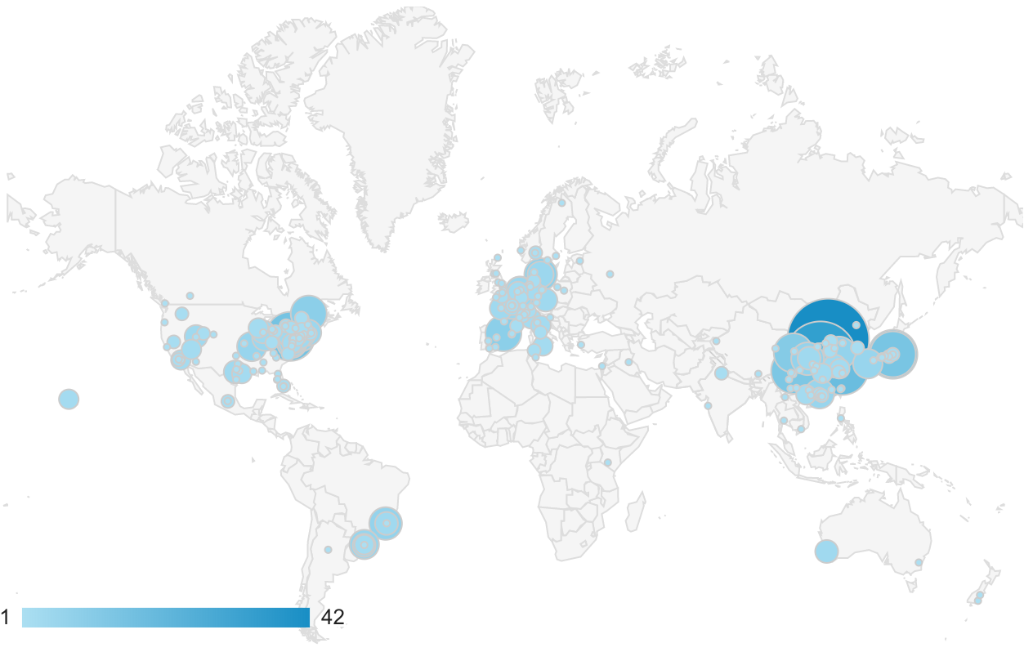

**Total: 1782 unique visitors (Sept 2018 – Sept 2019) (**[**http://mingsongli.com/acycle**](http://mingsongli.com/acycle)**)**

**Data source:** [**https://analytics.google.com**](https://analytics.google.com)

* **Dr. J. Fred Read** (Emeritus Professor of Sedimentary Geology, Dept of Geosciences, Virginia Tech)

**It is truly an amazing contribution to the geosciences community.** As someone who has spent much of the last 50 years trying to understand cyclic carbonates on shallow platforms, and having been involved with my students in some of the early work on stratigraphic modelling of the effects of Milankovitch forcing of carbonate platform stratigraphy, **I was blown away by the power of the**Acycle**software.** In the old days we used in house programs from our geophysicist Cahit Coruh, and recently I have used Analyseries, kSpectra and Timefrq43, moving from Dos to Windows to Mac, jumping from one to the other to get the job done. Acycle has done away with the need for this, and I have been impressed with how very user friendly the program is – an indication of the tremendous effort and thought that has gone into putting this together.

You should all feel very proud of this contribution. It opens up much needed access to these powerful tools for a wide audience in the sedimentary geology and paleoclimate community. Thanks again for all your efforts. **A really marvelous job.**

* **Dr. James G. Ogg** (Professor, Dept. Earth, Atmos. & Planet. Sci., Purdue University, USA):

“Mingsong Li’s ***Acycle*** software enables us to quickly analyze the potential of new outcrops and boreholes, and then to determine the sedimentation rates and elapsed time. His ***Acycle*** software will become the standard tool for time-scale applications by all international workers.”

* **Dr. Paul E. Olsen** (Professor of Earth and Environmental Sciences, Columbia University; Member, National Academy of Sciences of the USA):

“Not only is this software powerful and effective, it is also simple to use and therefore benefits researchers and at all levels within the paleoclimatology community, from novices to experts.”

* **Dr. Arsenio Muñoz Jiménez (Department of Earth Sciences, University of Zaragoza, Spain):**

“Thank you very much and congratulations for the ***acycle*** software. I am using it and it is very very useful and interesting.”

* **Dr. Marco Franceschi** (Professor, Department of Geosciences, University of Padova, Italy):

“Dr. Li’s software is being immensely valuable to my work. Some of the stratigraphic series I am studying display a prominent cyclicity, but were deposited in contexts characterized by relevant changes in sedimentation rates and often lack accurate geochronological constraints. ***Acycle*** has been designed specifically for dealing with similar cases, by tackling them with a rigorous statistical approach, and therefore is providing an invaluable tool for their investigation.”

* **Dr. Xu Yao** (School of Earth Sciences, Lanzhou University, China):

“I am working on cyclostratigraphy and paleoclimate study of ancient strata and rocks (270 million years ago) with assistance from ***Acycle*** software. I also introduced this software to my colleagues whose research areas are paleoclimate implications of Quaternary loess (several thousand years ago). My colleagues have given me really good feedbacks about ***Acycle*** software.”

* **Dr. Christian Zeeden** (IMCCE, Observatoire de Paris, France):

“Dr. Li’s software is novel and valuable in this context, especially because it facilitates the easy application of otherwise complex calculations.”

* **Dr. Nicolas R. Thibault** (University of Copenhagen, Denmark):

“I’ve been playing a lot with the excellent ***Acycle*** package for Matlab that Mingsong developed. Congratulations, this is a very nice interface that simplifies a lot our work and makes it truly faster to analyse a time-series.”

# **1. Copyright**

Copyright © 2017-2019.

This software can be freely downloaded, used, and shared by all users. It can be redistributed and/or modified under the terms of the GNU GENERAL PUBLIC LICENSE as published by the Free Software Foundation. To obtain a copy of the GNU General Public License, go to: <https://www.gnu.org/licenses>.

This program is distributed in the hope that it will be useful, but WITHOUT ANY WARRANTY; without even the implied warranty of MERCHANTABILITY or FITNESS FOR A PARTICULAR PURPOSE.

The *Acycle* authors reserve the right to license this program or modified versions of *Acycle* under other licenses at the discretion. Questions about *Acycle* may be directed to:

|  |  |
| --- | --- |
| *Mingsong Li*  *Assistant Research Professor*  *Department of Geosciences*  *Pennsylvania State University*  *University Park, PA 16802, USA*  *E-mail: mul450@psu.edu or limingsonglms@gmail.com* | *Linda A. Hinnov*  *Professor*  *Department of Atmospheric, Oceanic and Earth Sciences*  *George Mason University*  *Fairfax, VA 22030*  *E-mail: lhinnov@gmu.edu*  *Website: http://mason.gmu.edu/~lhinnov/* |

***Acycle* Authors:**

Mingsong Li (Pennsylvania State University)

Linda A. Hinnov (George Mason University)

**Contributors:**

Jacques Laskar, Richard Zeebe (Astronomical Solutions)

Jonathan Levine, Peter Huybers (Insolation)

Stephen Meyers (TimeOpt/eTimeOpt)

Matthias Sinnesael (Spectral Moments)

Christopher Torrence, Gilbert Compo (Wavelet)

Jeffrey Park (Multitaper Adaptive Weighting, Harmonic F-Test)

Eric Ruggieri (Bayesian Change Point)

Nicolas R. Thibault (Padding for EvoFFT)

**Acknowledgments:**

Feng Cheng, Anne-Christine Da Silva, Hewei Duan, Yanan Fang, Marco Franceschi, Daniel R. Franco, Xiaoni Hu, Dorothée Husson, Arsenio Muñoz Jiménez, Lee R. Kump, Dongyang Liu, Kunyuan Ma, Mathieu Martinez, James Ogg, Paul Olsen, Jeffrey Park, J. Fred Read, Chen Shen, Chuanyue Wang, Meng Wang, Xu Yao, Qiyan Zhang, Yang (Wendy) Zhang, Christian Zeeden

**Advice and suggestions are always greatly appreciated. ​​​​​​​**

# **2. References**

Please acknowledge *Acycle* on any publication of scientific results that is based on the use of *Acycle* and cite the following article in which *Acycle* is described:

**Li, M., Hinnov, L.A., and Kump, L.R. 2019. *Acycle*: Time-series analysis software for paleoclimate projects and education, *Computers & Geosciences*, 127: 12-22. https://doi.org/10.1016/j.cageo.2019.02.011**

If you publish results using the following methods, please cite the indicated publications:

**Correlation coefficient** (**COCO or eCOCO**):

* Li, M., Kump, L.R., Hinnov, L.A., Mann, M.E., 2018. Tracking variable sedimentation rates and astronomical forcing in Phanerozoic paleoclimate proxy series with evolutionary correlation coefficients and hypothesis testing. *Earth and Planetary Science Letters* 501, 165-179, <https://doi.org/10.1016/j.epsl.2018.08.041>.

**Bayesian Changepoint**:

* Ruggieri, E., 2013. A Bayesian approach to detecting change points in climatic records. International Journal of Climatology 33, 520-528, <https://doi.org/10.1002/joc.3447>.

**Evolutionary fast Fourier Transform (evoFFT)**:

* Kodama, K.P., Hinnov, L., 2015. *Rock Magnetic Cyclostratigraphy*. Wiley-Blackwell, 165 p., <https://doi.org/10.1002/9781118561294>.

**eTimeOpt**: see TimeOpt

**Filtering** (Gauss and Taner filters):

* Kodama, K.P., Hinnov, L.A., 2015. *Rock Magnetic Cyclostratigraphy*. Wiley-Blackwell, 165 p., <https://doi.org/10.1002/9781118561294>

**Multitaper data adaptive weighting and harmonic F-test**:

* From an unpublished SCILAB script by Jeffrey Park, Department of Geology and Geophysics, Yale University.

**Power decomposition analysis** (***pda.m***):

* Li, M., Huang, C., Hinnov, L.A., Ogg, J., Chen, Z.-Q., and Zhang, Y., 2016. Obliquity-forced climate during the Early Triassic hothouse in China. *Geology,* 44, 623-626, <https://doi.org/10.1130/G37970.1>

**Red noise modeling**:

**Classic AR(1)**

* Husson, D., 2014. MathWorks File Exchange: RedNoise_ConfidenceLevels, <https://www.mathworks.com/matlabcentral/fileexchange/45539-rednoise_confidencelevels> with corrections by L.A. Hinnov.

**Robust AR(1)**

* Mann, M.E., and Lees, J.M., 1996. Robust estimation of background noise and signal detection in climatic time series. *Climatic Change*, 33, 409-445, <https://doi.org/10.1007/BF00142586>.

**Sedimentary noise model** (**DYNOT** or ***ρ*1**):

* Li, M., Hinnov, L.A., Huang, C., Ogg, J., 2018. Sedimentary noise and sea levels linked to land–ocean water exchange and obliquity forcing. *Nature Communications*, 9, 1004, <https://doi.org/10.1038/s41467-018-03454-y>

**Spectral Moments**:

* Sinnesael, M., Zivanovic, M., De Vleeschouwer, D., Claeys, P., 2018. Spectral Moments in Cyclostratigraphy: Advantages and Disadvantages compared to more classic Approaches. *Paleoceanography and Paleoclimatology* 33, 493–510. <https://doi.org/10.1029/2017PA003293>.

**TimeOpt**:

* Meyers, S.R., 2015. The evaluation of eccentricity-related amplitude modulation and bundling in paleoclimate data: An inverse approach for astrochronologic testing and time scale optimization. *Paleoceanography*, 30, <https://doi.org/10.1002/2015PA002850>
* Meyers, S.R., 2019. Cyclostratigraphy and the problem of astrochronologic testing. *Earth-Science Reviews* 190, 190-223, <https://doi.org/10.1016/j.earscirev.2018.11.015>

**Wavelet analysis**:

* Torrence, C., Compo, G.P., 1998. A practical guide to wavelet analysis. *Bulletin of the American Meteorological Society*, 79, 61-78, [https://doi.org/10.1175/1520-0477(1998)079<0061:APGTWA>2.0.CO;2](https://doi.org/10.1175/1520-0477(1998)079%3c0061:APGTWA%3e2.0.CO;2).

**Astronomical solutions**

**Berger & Loutre 1991**

Berger, A., Loutre, M.-F., 1991. Insolation values for the climate of the last 10 million years. Quaternary Science Reviews 10, 297-317.

**La2004**

Laskar, J., Robutel, P., Joutel, F., Gastineau, M., Correia, A.C.M., Levrard, B., 2004. A long-term numerical solution for the insolation quantities of the Earth. Astronomy & Astrophysics, 428, 261-285, <https://doi.org/10.1051/0004-6361:20041335>.

**La2010**

Laskar, J., Fienga, A., Gastineau, M., Manche, H., 2011. La2010: a new orbital solution for the long-term motion of the Earth. Astronomy & Astrophysics, 532. <https://doi.org/10.1051/0004-6361/201116836>.

* ***calculation method presented in***

Wu, H., Zhang, S., Jiang, G., Hinnov, L., Yang, T., Li, H., Wan, X., Wang, C., 2013. Astrochronology of the Early Turonian-Early Campanian terrestrial succession in the Songliao Basin, northeastern China and its implication for long-period behavior of the Solar System. Palaeogeography, Palaeoclimatology, Palaeoecology 385, 55-70, <https://doi.org/10.1016/j.palaeo.2012.09.004>.

**ZB2017**

Zeebe, R.E., 2017. Numerical solutions for the orbital motion of the Solar System over the past 100 Myr: limits and new results. *The Astronomical Journal*, 154, 193, <https://doi.org/10.3847/1538-3881/aa8cce>

**ZB18a**

Zeebe, R.E., Lourens, L.J., 2019. Solar System chaos and the Paleocene–Eocene boundary age constrained by geology and astronomy, *Science*, 365, 926-929, <https://doi.org/10.1126/science.aax0612>.

# **3. Software Specifications**

## **3.1 System Requirements**

This software was developed in **MatLab version 2019a**. It was tested in the Mac OS Mojave (10.14) and Catalina (10.15), and Windows 7 and 10.

|  |
| --- |
| **Facts for stand-alone versions of *Acycle*:**  * **If you have MatLab 2019a, MatLab Runtime 2019a is already installed**  **\* Stand-alone versions of *Acycle* only needs Runtime, not MatLab**  **\* MatLab Runtime is not MATLAB**  **\* MatLab Runtime is free**  **\* Use MatLab Runtime 2019a; other versions of runtime may NOT work** |

[**1. MatLab version**]:

This version works with both Mac OS and Windows. MatLab is essential for the *Acycle* software package. Specified MatLab toolboxes may be needed.

[**2. Mac version**]:

This software is a stand-alone program. It was tested in the Mac OS Mojave (10.14) and Catalina (10.15). If the Mac runs with no MatLab, MatLab runtime 2019a is essential for the *Acycle* stand-alone software.

Two versions are available:

v1. *Acycle*X.X-Mac-green

**No installation needed**.

Size: ~100 Mb.

MatLab Runtime **2019a** is not included in this package and can be downloaded at: <https://www.mathworks.com/products/compiler/matlab-runtime.html>.

v2. *Acycle*X.X-Mac-Installer

Install MatLab Runtime **2019a** ahead, and then install *Acycle*.

Size: ~100 Mb

[**3. Windows version**]:

This software is a stand-alone program. It was tested in Windows 10 and 7.

v1. *Acycle*X.X-Win-green

v2. *Acycle*X.X-Win-Installer

Size: ~100 Mb.

If the computer runs with no MatLab 2019a, MatLab Runtime **R2019a** is essential for the *Acycle* stand-alone software.

## **3.2 Downloading the *Acycle* software**

The *Acycle* software is available for download from:

**Dropbox** (<https://www.dropbox.com/sh/t53vjs539gmixnm/AAC0BqTR0U5xghKwuVc1Iwbma?dl=0>),

**OneDrive** (<https://1drv.ms/u/s!AuOnvtrY8aRzhG17NCoXG14eOVIS>), or

**Baidu Cloud** (<https://pan.baidu.com/s/14-xRzV_-BBrE6XfyR_71Nw>)

**MatLab version only here:**

**GitHub** ([*https://github.com/mingsongli/acycle/*)](https://github.com/mingsongli/acycle/)),

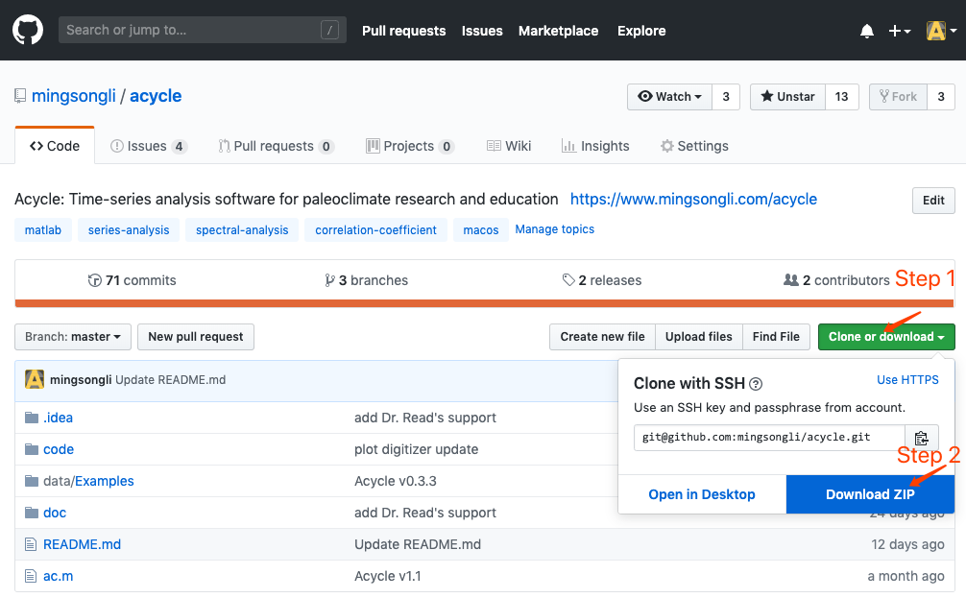

## **3.3 MatLab version**

### **3.3.1 Installation**

Unzip the *Acycle* software package to your root directory. No installation is needed.

### **3.3.2 Startup**

**Step 1**: Start MatLab.

**Step 2**: Change the MatLab working directory to the *Acycle* directory.

You may use the icon in blue Box 1 or type the directory in blue Box 2 below.



**Step 3**: Launch ac.m

Option 1: Type **ac** in MatLab’s command window, then press the Enter key.

Option 2: Right click ac.m file and choose Run.

Then, all set!



## **3.4 Mac version**

### **3.4.1 Introduction**

This version of *Acycle* is a stand-alone program. It is tested in Mac OS Mojave (10.14) and Catalina (10.15). Two versions are available:

**Section 3.4.2** *Acycle*X.X-Mac-green

**Section 3.4.3** *Acycle*X.X-Mac-Installer

### **3.4.2 *Acycle*X.X-Mac-green**

3.4.2.1 Download *Acycle*X.X-Mac-green

**Dropbox** (<https://www.dropbox.com/sh/t53vjs539gmixnm/AAC0BqTR0U5xghKwuVc1Iwbma?dl=0>), or

**Baidu Cloud** (<https://pan.baidu.com/s/14-xRzV_-BBrE6XfyR_71Nw>).

3.4.2.2 Installation of MatLab Runtime

Step 1: Download “MCR_2019a_maci64_installer.zip” here:

<https://www.mathworks.com/products/compiler/matlab-runtime.html>

Step 2: Install for mac OS. Double click the file blue box below (left panel).

Or right-click and select “Show Package Contents”. In the pop-up folder, double click “InstallForMacOSX”. Then it may ask permission for installation. Follow instructions of the MatLab Runtime installer, you will be guided to install Runtime.

 

Step 3. Setup Runtime environment (optional? detailed in Box 1).

Step 1: Drag “AcyclevX.X-Mac” file to “/Applications” folder.

**Box 1** [**How to set the MatLab Runtime environment variable DYLD_LIBRARY_PATH?**]

Here is a nice answer by Walter Roberson on 14 Jan 2016.

<https://www.mathworks.com/matlabcentral/answers/263824-mcr-with-mac-and-environment-variable>

Step 1: Go into the Terminal app (it is under /Applications/Utilities).

While you are at the Terminal command window, command

ls ~/.bashrc

If it says that the file does not exist, then in the Terminal window, command

touch ~/.bashrc

if it doesn’t work, you may try

nano ~/.bashrc

to create the file. If the file already exists or you have now created it, then at the terminal window command

open ~/.bashrc

This will open TextEdit. In TextEdit you can add the line

export DYLD_LIBRARY_PATH=/Applications/MATLAB/MATLAB_Runtime/v96/runtime/maci64:/Applications/MATLAB/MATLAB_Runtime/v96/sys/os/maci64:/Applications/MATLAB/MATLAB_Runtime/v96/bin/maci64:/Applications/MATLAB/MATLAB_Runtime/v96/extern/bin/maci64

to the end of the file, and then you can use the TextEdit File menu to Save the file.

If your SHELL showed up as csh or tcsh, or in any case if you just want to be more thorough, then you can use the same kind of steps as just above:

ls ~/.cshrc

and if it does not exist, "touch ~/.cshrc", and then once it exists, "open ~/.cshrc", and then in TextEdit, add the line they gave in the instructions,

setenv DYLD_LIBRARY_PATH

=/Applications/MATLAB/MATLAB_Runtime/v96/runtime/maci64:/Applications/MATLAB/MATLAB_Runtime/v96/sys/os/maci64:/Applications/MATLAB/MATLAB_Runtime/v96/bin/maci64:/Applications/MATLAB/MATLAB_Runtime/v96/extern/bin/maci64

and save.

These changes will not affect your current Terminal session, but they will affect the next time you start a Terminal session or anything else starts an interactive shell.

3.4.2.3 Startup *Acycle*X.X-Mac-green

*You only need to do Steps 1-3 for the first time. Then only Step 4 below is need.*

Step 1: Drag the *Acycle*X.X-Mac file to the /Applications folder.

Step 2: Go to the “/Applications” folder. Right click “*Acycle*X.X-Mac” file, choose “Show Package Content”.



Step 3: Go to “/Contents/MacOS” folder, drag the “applauncher” file to dock (**NOT** the “*Acycle*” file).

Step 4: Click icon of “applauncher” in the dock to start the *Acycle* software.

Note the first-time run will be very slow.

Warning: NEVER close the terminal window (left panel below) when using *Acycle*. This will close *Acycle*.



 

### **3.4.3 *Acycle*X.X-Mac-Installer**

3.4.3.1 Download *Acycle*X.X-Mac-Installer

**Dropbox** (<https://www.dropbox.com/sh/t53vjs539gmixnm/AAC0BqTR0U5xghKwuVc1Iwbma?dl=0>), or

**Baidu Cloud** (<https://pan.baidu.com/s/14-xRzV_-BBrE6XfyR_71Nw>).

3.4.3.2 Installation of MatLab Runtime and *Acycle* simultaneously.

Step 1: Double click “*Acycle*X.X-Mac-Installer” to start the installation. The admin permission may be required.

Step 2: Following instructions of *Acycle* Installer.

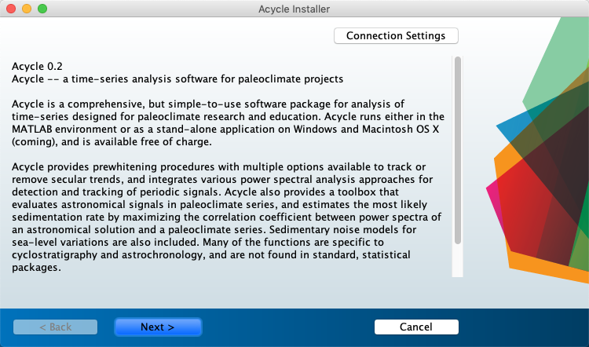Choose *Acycle* installation folder (default folder is /Applications/*Acycle*).

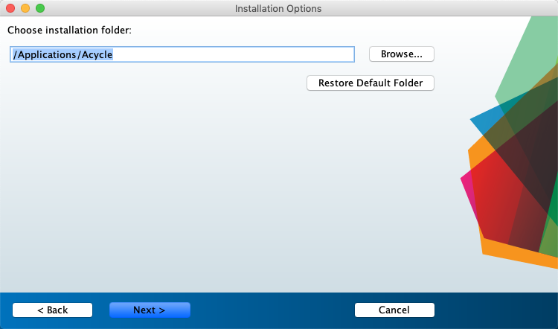

Step 3: Choose MATLAB Runtime installation folder (default folder is /Applications/MATLAB/MATLAB_Runtime).

Step 4: License Agreement: Do you accept the terms of the license agreement? You may select Yes.

Step 5: Install *Acycle*.

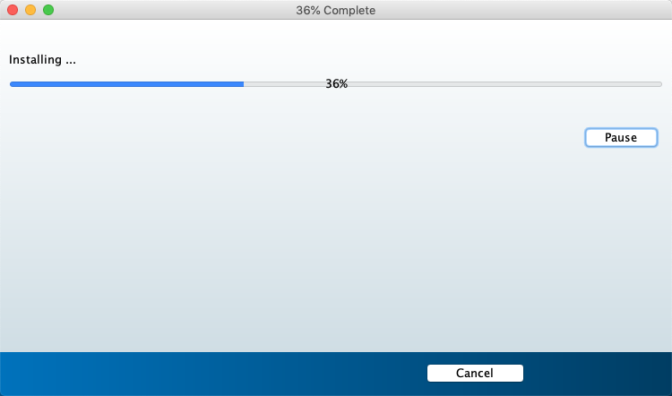

**Setup Runtime environment (optional? detailed in Box 2).**

3.3 Startup *Acycle*X.X-Mac

Box 2 [**How to set the MatLab Runtime environment variable DYLD_LIBRARY_PATH?**]

Here is a nice answer by Walter Roberson on 14 Jan 2016.

<https://www.mathworks.com/matlabcentral/answers/263824-mcr-with-mac-and-environment-variable>

Step 1: Go into the Terminal app (it is under /Applications/Utilities).

While you are at the Terminal command window, command

ls ~/.bashrc

If it says that the file does not exist, then in the Terminal window, command

touch ~/.bashrc

if it doesn’t work, you may try

nano ~/.bashrc

to create the file. If the file already exists or you have now created it, then at the terminal window command

open ~/.bashrc

This will open TextEdit. In TextEdit you can add the line

export DYLD_LIBRARY_PATH=/Applications/MATLAB/MATLAB_Runtime/v96/runtime/maci64:/Applications/MATLAB/MATLAB_Runtime/v96/sys/os/maci64:/Applications/MATLAB/MATLAB_Runtime/v96/bin/maci64

to the end of the file, and then you can use the TextEdit File menu to Save the file.

If your SHELL showed up as csh or tcsh, or in any case if you just want to be more thorough, then you can use the same kind of steps as just above:

ls ~/.cshrc

and if it does not exist, "touch ~/.cshrc", and then once it exists, "open ~/.cshrc", and then in TextEdit, add the line they gave in the instructions,

setenv DYLD_LIBRARY_PATH

/Applications/MATLAB/MATLAB_Runtime/v96/runtime/maci64:/Applications/MATLAB/MATLAB_Runtime/v96/sys/os/maci64:/Applications/MATLAB/MATLAB_Runtime/v96/bin/maci64

and save.

These changes will not affect your current Terminal session, but they will affect the next time you start a Terminal session or anything else starts an interactive shell.

3.4.3.3 Startup *Acycle*X.X-Mac

You only need to do Steps 1-3 for the first run. Then only Step 4 below is need.

Step 1: Go to the installation folder (for example: /Applications/*Acycle*/application).

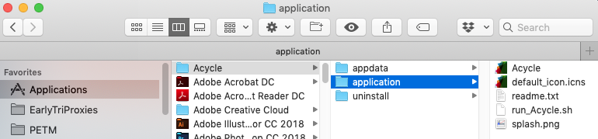

Step 2: Right click “*Acycle*” file, choose “Show Package Content”

Step 3: Go to the “Contents/MacOS” folder, drag the “applauncher” file to dock.

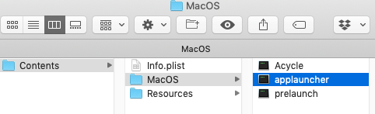



Step 4: Click icon of “applauncher” above to start the *Acycle* software.

Warning: NEVER close the terminal window (panel below) when using *Acycle*. This will close *Acycle* either. To kill *Acycle* software, press CTRL + C keys

Note the first-time run will be very slow. Please ignore various warning messages and forgive my naïve program skills.

Warning: the working directory should contain NO SPACE or no language other than ENGLISH.

## **3.5 Windows version**

### **3.5.1 Introduction**

This version of *Acycle* is a stand-alone program. It has been tested in Windows 10. Two versions are available:

### **3.5.2 *Acycle*X.X-Win-Installer**

3.5.2.1 Download *Acycle*X.X-Win-Installer

**Dropbox** (<https://www.dropbox.com/sh/t53vjs539gmixnm/AAC0BqTR0U5xghKwuVc1Iwbma?dl=0>), or

**Baidu Cloud** (<https://pan.baidu.com/s/14-xRzV_-BBrE6XfyR_71Nw>).

3.5.2.2 Installation

**It is recommended to install MatLab Runtime BEFORE the installation of *Acycle*.**

Double click “*Acycle*Installer.exe” to install *Acycle* and MatLab Runtime **R2019a**. Following the instructions, you will get everything set.

Downloading MatLab Runtime **R2019a** can take a lot of time. The Runtime needs 1.7 GB space.

3.5.2.3 Start-up

You could just double click the ***Acycle*** icon on the desktop to start or start from the Windows “All Program” menu like any other software.

**Now, you need to change the working directory () to the working folder (e.g., C:\test). The default folder may be windows “system32” folder, at which *Acycle* doesn’t have the permission to work.**

Warning: the working directory should contain NO SPACE or no language other than ENGLISH.

Warning: the first-time start-up can be very slow. Never close the command window when *Acycle* is running. The commend window will keep on showing information when it runs time-consuming steps.

### **3.5.3 *Acycle*X.X-Win-green**

3.5.3.1 Download *Acycle*X.X-Win-green, unzip the file.

**Dropbox** (<https://www.dropbox.com/sh/t53vjs539gmixnm/AAC0BqTR0U5xghKwuVc1Iwbma?dl=0>), or

**Baidu Cloud** (<https://pan.baidu.com/s/14-xRzV_-BBrE6XfyR_71Nw>).

3.5.3.2 Installation of MatLab Runtime 2019a

<https://www.mathworks.com/products/compiler/matlab-runtime.html>

3.5.3.3 Double click “*Acycle*.exe” to run *Acycle*.

3.5.3.4 Now, you need to change directory () to the working folder.

## **3.6 Data Requirements**

The input file of data series can be in a variety of formats, including comma-, table- or space-delimited text (*\*.txt*), or comma-separated values files (*\*.csv*) from an Excel-type spreadsheet. No header is permitted.

The data files must contain two columns of values. The first column must be in depth or time, and the second column is value for the corresponding depth or time.

**

Make sure that there are NO SPACES or language other than ENGLISH in the address line (above). Or you need to change the directory () to another working folder.

*??? Still have no idea, don't worry. Try this, you’ll have a perfect example:*

*Choose “Basic Series” menu 🡪 Examples 🡪 choose any data or image file*

**

The data will be saved in the working directory. All data files, plots, and folders are displayed in the GUI list box.

# **4. *Acycle* graphical user interface (GUI)**



*Acycle* Graphical User Interface (GUI)

## **4.1 Functions and GUI**

*Acycle* contains the following functions.

**File**

New Folder; New Text File; Save *.AC.fig; Open Working Directory; Extract Data

**Edit**

Refresh; Rename; Cut; Copy; Paste; Delete

**Plot**

Plot; Plot Pro; Plot Standardized; Plot Swap Axis; Stairs, Sampling Rate; Data Distribution

**Basic Series**

Insolation; Astronomical Solution; Signal/Noise Generator; LR04 Stack; Examples (a couple of data series of data and images)

**Math**

Sort/Unique/Delete-empty; Interpolation; Select Parts; Merge Series; Add Gaps; Remove Parts; Remove Peaks; Clipping; Smoothing[Moving Average, Moving Median, Bootstrap]; Changepoint; Sampling Rate Sensitivity; Standardize; Principal Component; Log-transform; Derivative; Simple Function; Utilities[Find Max/Min]; Image[Show Image, RGB to Grayscale; Image Profile]; Plot Digitizer

**Time series**

Detrending | Curve Fitting; Pre-whitening [First Difference]; Spectral Analysis; Evolutionary Spectral Analysis; Wavelet transform; Filtering; Amplitude Modulation; Build Age Model; Age Scale; Sedimentary Rate to Age Model; Power Decomposition Analysis; Sedimentary noise model (DYNOT; *ρ*1 method); Correlation Coefficient (COCO/eCOCO); TimeOpt method; eTimeOpt method; Spectral Moments

**Help**

What’s New; Manuals; Find Updates; Copyright

## **4.2 File**

**New Folder:**

make a new empty folder with a user-defined folder name.

*Question: Why do you need this tool?*

*Answer: You want to keep your data files well-organized. I make new folders for each project.*

**New Text File:**

make a new empty *.txt file with a user-defined file name.

***Shortcut keys [Mac]: ⌘ + N; [Windows]: Ctrl + N***

**Save *.AC.fig file:**

Save the current figure as an *.ac.fig file. This file enables users continue a suspended project.

For example, after running the eCOCO (evolutionary correlation coefficient), users may want to plot the eCOCO results anytime. One can save the current figure as an *.AC.fig file, then double click this *.AC.fig file and show “ECOCO plot” anytime.

**Extract Data:**

Extract 2 columns of data from a multiple columns data file.

## **4.3 Edit**

**Refresh:** refresh the main listbox.

***Shortcut keys [Mac]: ⌘ + R; [Windows]: Ctrl + R***

**Rename:**

Select one file, the “rename” function enable changing the name of the selected file.

**Cut/Copy/Paste/Delete:**

 

## **4.4 Plot**

**Plot:**

A quick plot of the selected data file. ***Shortcut keys [Mac]: ⌘ + D; [Windows]: Ctrl + D***

**Plot Pro:**

An advanced plot of the selected data file (GUI below). One can change plot type, line, and marker styles, and control the axis. ***Shortcut keys [Mac]: ⌘ + P; [Windows]: Ctrl + P***

 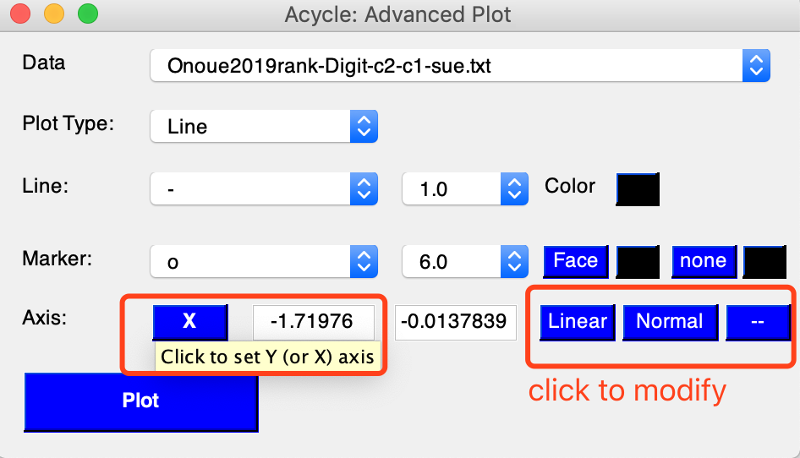

One example



**Plot Standardized:**

A quick plot of the standardized data file. Useful if one wants to compare 2 or more series.

**Plot Standardized +2:**

A quick plot of the standardized data file. Useful if one wants to compare 2 or more series.

**Plot Swap Axis:**

A quick plot, swap axis.

**Stairs:**

Stairs plot.

**Sampling Rate:**

A quick plot showing the distribution of the 1st column (time/depth) of the selected data file.

**Data Distribution:**

A quick plot showing the distribution of the 2nd column (data) of the selected data file.

## **4.5 Basic Series**

### **Insolation**

A GUI calculates the insolation using various astronomical solutions, based on the MatLab script **insolationnjl.m** by Jonathan Levine (2001; now at the Department of Physics and Astronomy, Colgate University, <https://www.colgate.edu/about/directory/jlevine>; must contact for script), that was modified to **daily_insolation.m** (<https://eisenman-group.github.io/daily_insolation.m> ) by Peter Huybers (Harvard) and Ian Eisenman (UC San Diego), and edited by Mingsong Li for the *Acycle* software.

Only insolation series younger than 249,000 Ka are available for the Laskar solutions.

*Tips: If it can only save the first calculation, one solution is: close the “Acycle-Insolation” GUI and redo the calculation. Then Acycle will “forget” the “previous run” and save data correctly.*

***Shortcut keys [Mac]: ⌘ + 1; [Windows]: Ctrl + 1***

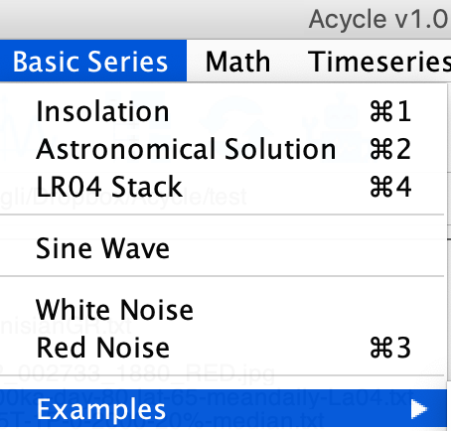 



*This GUI generates the mean daily insolation series on March 21 for the 1-1000 Ka at 65°N using the La2004 solution with a solar constant of 1365 w/m2.*

### **Astronomical Solution**

A GUI generates astronomical solutions of Laskar et al. (2004); Laskar et al. (2011), Zeebe (2017), and (Zeebe and Lourens, 2019). ***Shortcut keys [Mac]: ⌘ + 2; [Windows]: Ctrl + 2***





*This GUI generates ETP series (sum of standardized eccentricity, tilt, and precession, weighted with 1, 1, and -1, respectively) for the past 1 million years from 1 Ka to 1000 Ka using the La2004 solution* (Laskar et al., 2004)*.*

### **Signal/Noise Generator**

A toolbox generating a 2-column time series of signal and noise using either pre-defined first column or user-defined first column.

Signal and noise models include (image below) polynomial, sine wave (or cosine wave), white noise, and red noise.

***Shortcut keys [Mac]: ⌘ + 3; [Windows]: Ctrl + 3***

**Polynomial**

Generate a line using user-defined coefficients of a polynomial.

**Sine wave**

Generate a sine wave using user-defined parameters and the following equation:

Y = A * sin(2π / T * X + Ph) + bias

Where A is amplitude, T is period, X is a time series ranges from *t1* to *t2* and a sampling rate of dt, Ph is the phase, and bias is signal bias.



*This GUI generates a sine wave from 1 to 1000 unit with a sampling rate of 1 unit. Its amplitude is 1, with a period of 100 unit and zero phase shift and 0 signal bias.*

**White Noise**

This function generates white noise with either normal distribution or random distribution using user-defined mean value and standard deviation.

**Red Noise**

This function generates the red noise using user-defined mean value, standard deviation, and autocorrelation coefficient (RHO-1 or α, from 0 to 1).



**1. Pre-defined first column signal or noise**

It will read the selected data file and copy the first column. Then it will generate the 2nd column using a user-selected signal or noise model. If a data file is selected in the *Acycle*, users won’t have access to change the first column.

For example,

Step 1: In the *Acycle* main window, select “Basic Series” – “Examples” – “Example-WayaoCarnianGR0.txt”.

Step 2: Select the newly generated file: “Example-WayaoCarnianGR0.txt”, and then click “Basic Series” – “Signal/Noise Generator”.

Step 3: Select “Sine Wave”, and set the period to 50 m. A sine wave will be displayed in the lower part of the “*Acycle*: Signal/Noise Generator”.

Step 4: Click “Save Data”. A sine wave data file will be saved and displayed in the *Acycle* main window.



**2. User-defined first column signal or noise**

It will generate both the first and the second columns using user-selected models.

For example,

Step 1: In the *Acycle* main window, de-select any data file.

Step 2: Click “Basic Series” – “Signal/Noise Generator”.

Step 3: Set X axis from 0 to 500 with a step of 1. Select “Red Noise” and set the mean to 5, alpha = 0.5. A red noise will be displayed in the lower part of the “*Acycle*: Signal/Noise Generator”.

Step 4: Click “Save Data”. A sine wave data file will be saved and displayed in the *Acycle* main window.



*Red noise series with a lag-1 auto-correlation coefficient (ρ) of 0.5. It looks like a climate series!*

### **LR04 Stack**

This function generates the classical LR04 stack of the Plio-Pleistocene benthic d18O record (Lisiecki and Raymo, 2005). The input time (below) should be within the interval of 0 and 5320 (Ka). ***Shortcut keys [Mac]: ⌘ + 4; [Windows]: Ctrl + 4***

 

*This GUI generates LR04 stack from 0 to 3000 Ka.*

### **Examples**

This function loads various example data files to the working folder and displays the data. The example data includes:



**(1) Mauna Loa CO2 monthly mean:**

This data set includes carbon dioxide measurements (monthly mean value) at the Mauna Loa Observatory, Hawaii from 1958 to 2018.

It will load and save a text file entitled: “Example-LaunaLoa-Hawaii-CO2-monthly-mean.txt”.

Ref: <https://www.esrl.noaa.gov/gmd/ccgg/trends/data.html>



**(2) Insolation 0-2Ma 65N Jun22:**

This data set includes insolation intensity data at latitude of 65 ° N on June 22 of each year over the past 2 million years, with a step of 1 kyr.

It will load and save a text file entitled: “Example-Insol-t-0-2000ka-day-80-lat-65-meandaily-La04.txt”.

**(3) La2004 0-2Ma ETP:**

This data set includes La2004 (Laskar et al., 2004) ETP (eccentricity, tilt, and precession) data over the past 2 million years, with a step of 1 kyr.

It will load and save a text file entitled: “Example-La2004-1E.5T-1P-0-2000.txt”.

**(4) Red Noise rho=0.7 2000 points:**

This data set includes a red noise time series with 2000 datapoints and a lag-1 autocorrelation coefficient of 0.7.

It will load and save a text file entitled: “Example-Rednoise0.7-2000.txt”.

**(5) PETM Svalbard logFe:**

This data set includes log-transformed iron series for the Paleocene-Eocene thermal maximum event in the Svalbard (Charles et al., 2011).

It will load and save a text file entitled: “Example-SvalbardPETM-logFe.txt”.



**(6) Late Triassic Newark Depth Rank:**

This data set includes depth rank series from the Late Triassic in the Newark Basin of the USA (Olsen and Kent, 1996).

It will load and save a text file entitled: “Example-LateTriassicNewarkDepthRank.txt”.



**(7) Late Triassic Wayao gamma ray:**

This data set includes gamma ray series from the Late Triassic (middle Carnian) Wayao section of South China (Zhang et al., 2015).

It will load and save a text file entitled: “Example-WayaoCarnianGR0.txt”.



**(8) Middle Triassic Guandao2 gamma ray:**

This data set includes gamma ray series from the Middle Triassic Guandao section of South China (Li et al., 2018b).

It will load and save a text file entitled: “Example-Guandao2AnisianGR.txt”.



**(9) Image from Mars’ HiRISE camera:**

This data set includes an image from Mars’ HiRISE camera.

It will show and save an image file entitled: “Example-HiRISE-PSP_002733_1880_RED.jpg”.

Ref: <https://www.uahirise.org/PSP_002878_1880>

**(10) Image for Plot Digitizer:**

This includes an image for the demonstration of the “Plot Digitizer” function.

It will show and save an image file entitled: “Example-PlotDigitizer.jpg”.

 

(9) (10)

## **4.6 Math**

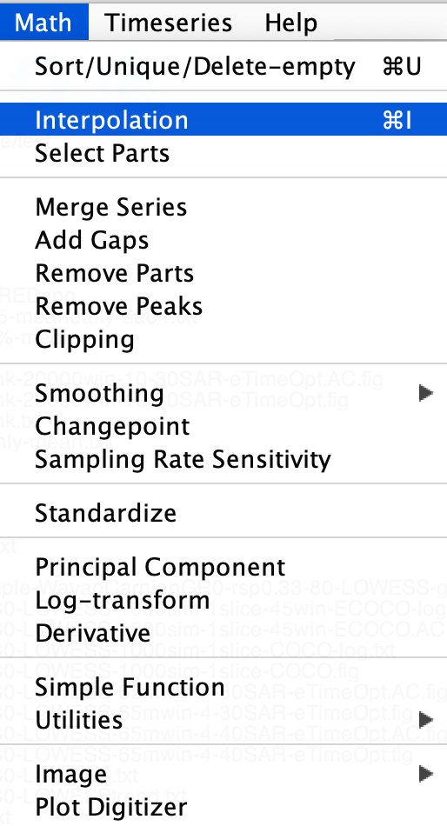

### **Sort/Unique/Delete-empty**

This function will sort the selected data file like MS Excel’s SORT function. If a dataset contains 2 or more data points with the same time/depth, then these data points will be replaced by their mean values.

***Shortcut keys [Mac]: ⌘ + U; [Windows]: Ctrl + U***

New file name: *-sue.txt or *-s.txt or *-u.txt

### **Interpolation**

Linear interpolation using MatLab’s *interp1* function.

***Shortcut keys [Mac]: ⌘ + I; [Windows]: Ctrl + I***

New file name: *-rsp0.3.txt, where 0.3 is user-defined interpolation sampling rate. Default value is the **median** of the sampling rate.

### **Select Parts**

This function generates a new series from the selected data using user-defined ‘start’ and ‘end’ of the interval.

New file name: *-a-b.txt, where a is the “start” and b is the “end”.

### **Merge Series**

Two selected series may be merged if their first columns are exactly the same.

New file name: mergedseries.txt.

### **Add Gaps**

This function generates a new series based on the selected data file via adding a gap or gaps using user-defined location and duration of the gap(s). Format, comma delimited:

10.5, 3.2

*Add a 3.2-unit gap at the depth/time of 10.5 unit, or*

10.5, 3.2, 13.3, 1.5

*Add a 3.2-unit gap at the depth/time of 10.5 unit and add the second 1.5-unit gap at the depth/time of 13.3 unit.*

### **Remove Parts**

This function generates a new series based on the selected data file via removing an user-defined interval(s). Format, comma delimited

15, 3, 20.2, 4

*Remove 3-unit data at the 15 unit (remove 15-18-unit data), and remove the second interval of 20.2-24.2-unit.*

### **Remove Peaks**

This function generates a new series based on the selected data file via converting any (2nd column) data higher than the user-defined Maximum value to that value and any data smaller than Minimum value to that value.

### **Clipping**

This function generates a new series based on the selected data file via clipping data higher or smaller than the user-defined threshold value.



*Raw and clipped insolation series*

### **Smoothing:**

### **Moving Average**

This function generates a new series based on selected data file using *n*-points smoothing, where *n* is a user-defined parameter.

New file name: *-3ptsm.txt, means 3 points smoothing output.

### **Moving Median**

This function generates a new series based on selected data file using *x%* median smoothing, where *x* is a user-defined parameter. The default value is 0.2 (20%).

New file name: *-20%-median.txt, means a 20% median smoothing output.

### **Bootstrap**

This function generates two new series based on selected data file using *user-defined* smoothing window, smoothing method, and number of bootstrap sampling.

New file name: *-WINDOW-METHOD-NUMBER-bootstp-meanstd.txt, mean and standard deviation data, and

*-WINDOW-METHOD-NUMBER-bootstp-percentile.txt, 0.5%, 2.275%, 15.865%, 50%, 84.135%, 97.725%, and 99.5% percentiles.

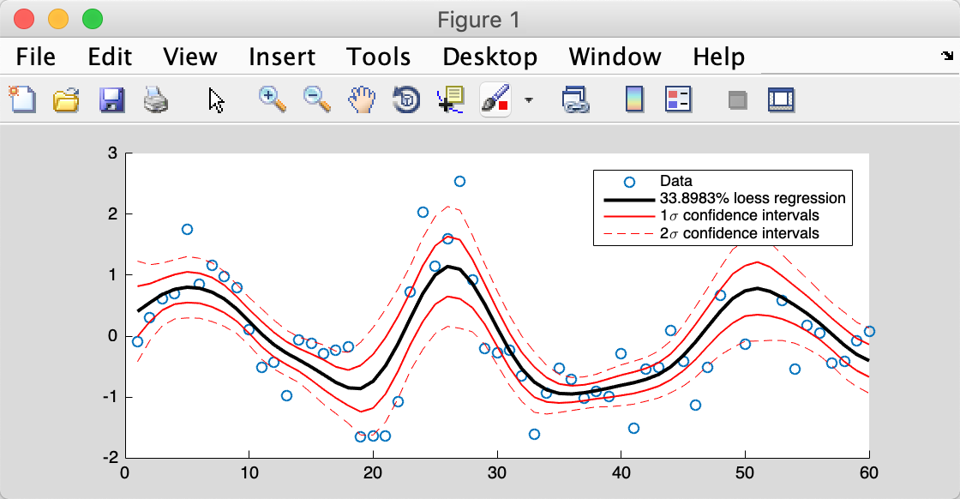

*This tool (Bootstrap Smoothing) is helpful for estimating confidence intervals of your dataset.*

### **Changepoint**

The Bayesian Change Point algorithm - a program to calculate the posterior probability of a change point in a time series.

Please acknowledge the program author on any publication of scientific results based in part on use of the program and cite the following article in which the program was described

E. Ruggieri (2013) "A Bayesian Approach to Detecting Change Points in Climatic Records," International Journal of Climatology, 33: 520-528. doi: 10.1002/joc.3447

Author: Eric Ruggieri

College of the Holy Cross

Worcester, MA 01610

Email: [eruggier@holycross.edu](mailto:eruggier@holycross.edu)



*This tool enables an objective detection of the “tipping” point at -157 m.*

### **Standardize**

Using MatLab’s *zscore* function.

Z = (X-u)/σ, where X is the second column data, u is the mean of X, and σ is the standard deviation of X.

New file name: *-stand.txt

### **Principal Component**

This function has different requirements of the data inputs. All column (including the first column) of data should be value, not depth or time.

### **Log-transform**

This function generates a new data file based on selected data file using log10 transformation of the second column of the selected data.

*Xi* = log10(*Xi*)

New file name: *-log10.txt

### **Derivative**

Approximate derivatives (first, second, third, …).

New file name: *-1derv.txt

### **Simple Function**

This function is very useful. It generates a new data file based on the selected data file. Both columns (1st or X column and 2nd or Y column) can be modified. See below case study.

*X(i) = a * X(i) + b*

*Y(i) = c * Y(i) + d*

*The selected data: all value in the first column data will be transformed using the equation X(i) = 1.5 * X(i) + 1; and all value in the second column data will be transformed using the equation Y(i) = 0.8 * Y(i) + (-3).*



New file name: *-new.txt

### **Utilities**

### **Find max/min**

Find max/min value within a user-defined interval. Output will be displayed in command window only.

### **Image:**

### **Show Image**

Plot selected image file.

### **RGB to Grayscale**

Convert a image file in RGB format to a grayscale format, save new image .

New image name: *-gray.tif

### **Image Profile**

Get the grayscale profile from a line constrained by two user-selected dots.

New file name: *-profile.txt % grayscale profile

New file name: *-controlpoints.txt % location of two control points

Step 1: Choose the image file, select “Math - Image – Image Profile” function.

Step 2: Click data cursor tool (**1**), press ALT key and click 2 points.

Step 3: For the **MatLab** version of *Acycle*: Press Enter key. Grayscale profile data will be picked up and saved along the green line.

* Step 3: **For the standalone version of *Acycle***: Go to the Mac terminal or Windows command window, press the Enter key.

### **Plot Digitizer**

Digitize data points from an image file. Example:

**Load “Example-PlotDigitizer.jpg” and run “Plot Digitizer”**

“Basic Series” 🡪 “Examples” 🡪 “Image for Plot Digitizer”.

Left click to select the image file (or your own image -- a plot with data points) in the *Acycle* main window, select “Math” 🡪 “Plot Digitizer” to run this GUI (see figures below).



 

You will see the pop-up window of “*Acycle*: Plot Digitizer” (top panel). Follow the instructions in **blue text** (bottom left corner):

**1) Click the “Calibrate axis” button**

**2) Pick-up axes limits**

In the image plot figure, click four points in the correct order: minimum limit of x-axis (2.1), maximum limit of x-axis (2.2), minimum limit of y-axis (2.3), and maximum limit of y-axis (2.4).

**3) Set axes limit values**

Return the window of “*Acycle*: Plot Digitizer”, type the value of x- and y- axis limits. And select “Linear” or “Log” model.

**4) Digitize**

Click “Digitize” button, you are able to click in the image figure to select data points.

Data points will be recorded and displayed in “Data Extra Tab” GUI.

Right click to terminate the digitizer; press “Digitize” to continue.

**5) Save Data**

Click “Save Data” button to save digitized data points in text files.

**6) Undo**

Press “Undo” to remove the last data point(s).

## **4.7 Time series**

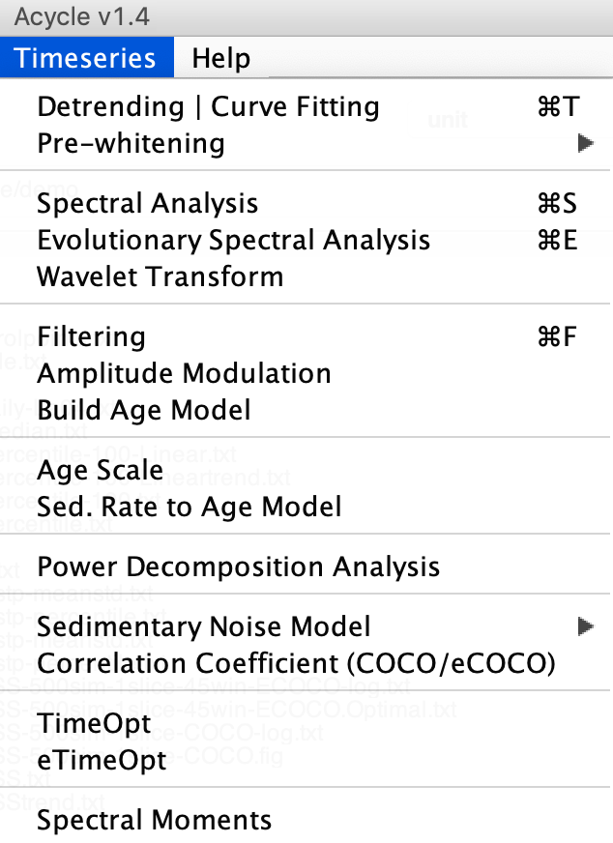

### **Detrending | Curve Fitting**

This detrending function generates 2 new data files based on the selected data file and user-defined parameters: window length and detrending method. Steps:

(0) Select a data file in the Main Window; Select **Timeseries** 🡪 **Detrending** menu

(1) Type a window length or a percentage or move the slider. Default value is 35% of the total length, that is, if a data length is 100 m, then a window is 35 m.

(2) Tick one or more detrending method

(3) Click OK button, wait for several seconds (up to a minute, depending on the length of the dataset and the speed of your machine). A new window (4) will popup showing the data and its 35% trend(s).

(5) In the “Select & Save detrending Model” panel, select the preferred trend. The trend and detrended file will be displayed in the Main Window.

(Tips) Change window sizes, the trend lines in the right panel will be updated automatically.

***Shortcut keys [Mac]: ⌘ + T; [Windows]: Ctrl + T***

New file names: *-80-LOWESS.txt AND *-80-LOWESStrend.txt

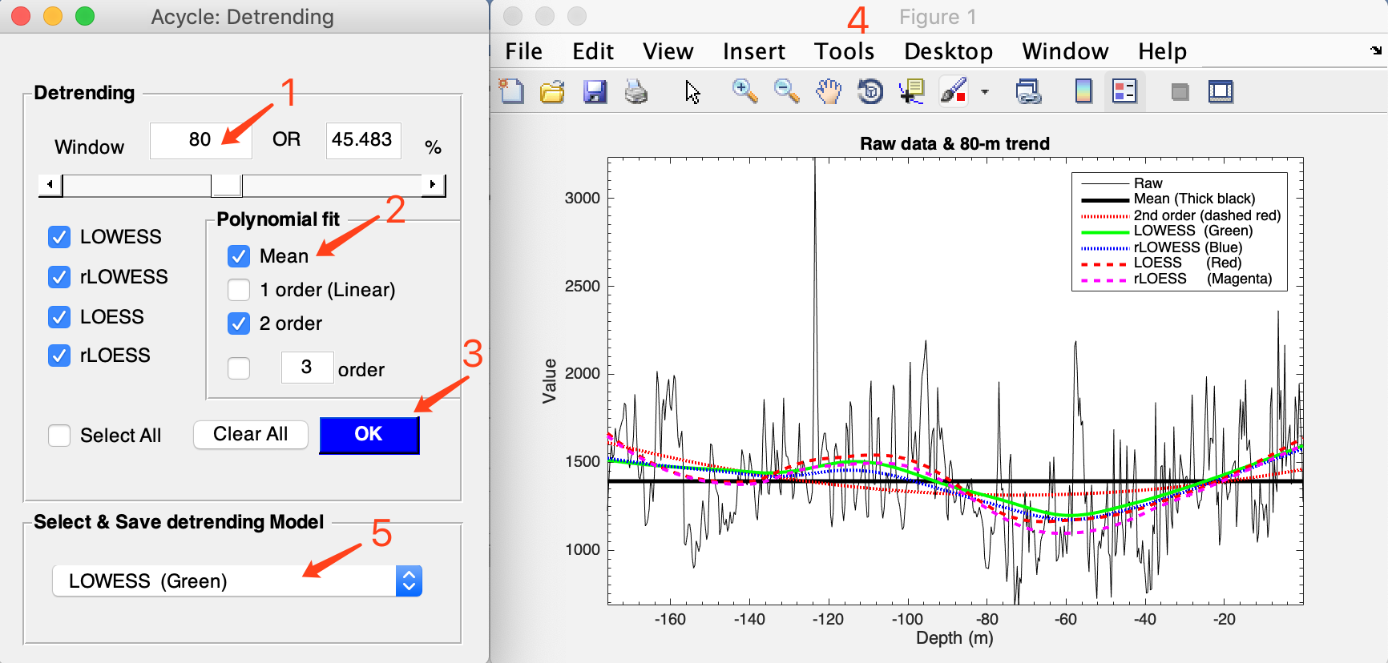

### **Prewhitening - First Difference**

Differences using MatLab’s diff function.

*Y* = diff(*X*), calculates differences between adjacent elements of *X*.

New file name: *-1stdiff.txt

### **Spectral Analysis**

This function conducts spectral analysis with user-defined parameters. Steps:

(1) Select a data file in the Main Window

(2) Select **Timeseries** 🡪 **Spectral Analysis** menu

(3) Select one method for spectral analysis. Options are Multi-taper method (MTM) (Thomson, 1982), Lomb-Scargle spectrum (Lomb, 1976; Scargle, 1982), and MatLab’s periodogram.

(4) If Multi-taper method (MTM) is selected, then the Method panel may be changed. The default uses three 2π prolate tapers with no zero-padding. Users can use any positive real number ** before π; the number of tapers that will be used is 2** -1 truncated to the nearest integer.

(5) Plot panel: set the max frequency in the coming figure. Linear or log model for x axis and y axis.

(6) Red Noise panel: AR(1) noise model using RedNoise.m by Husson (2014) and corrected by Linda Hinnov. Robust AR(1) noise model follows Mann and Lees (1996).

(7) Run or Run & Save button, generates power spectrum (and save power spectrum data and AR(1) series)

***Shortcut keys [Mac]: ⌘ + S; [Windows]: Ctrl + S***

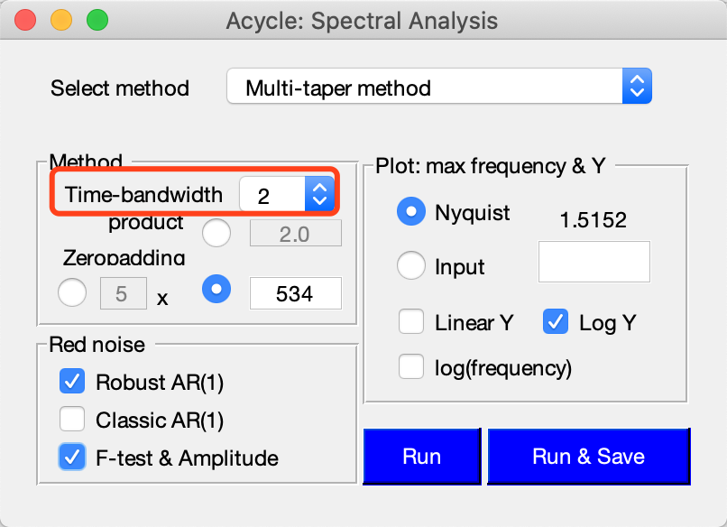 

Here, “0.2” means 20% median smoothing of frequency curve with a “1” cycle/m (input) max frequency.



*2π multitaper power spectrum of the Wayao Carnian gamma ray data (interpolation = 0.33; detrend 80-m lowess trend)*



*Amplitude and F-test significance spectra of the Wayao Carnian gamma ray series (interpolation = 0.33; detrend 80-m lowess trend)*

New files:

*-2piMTM-RobustAR1.txt, means 2π multitaper and confidence level series using Robust AR(1) noise model.

*-2piMTM-ClassicAR1.txt, means 2π multitaper and confidence level series using RedNoise.m by Husson (2014).

*-2piMTM-amp.txt, means 2π multitaper and amplitude series.

*-2piMTM-fsig.txt, means 2π multitaper and f-test significance level series.

*-2piMTM-ftest.txt, means 2π multitaper and f-test value series.

### **Evolutionary Spectral Analysis**

This function conducts evolutionary spectral analysis with user-defined parameters.

Steps:

(1) Select a data file in the Main Window. For example, click “Basic Series” – “Examples” – “Late Triassic Wayao gamma ray”. This opens the data file “Example-WayaoCarnianGR0.txt”. Let’s use “Math” – “Sort/Unique/Delete-empty” and “Interpolation” tools to ensure the format is supported by *Acycle* (i.e., increasing order and unique sampling rate). This will generate a file “Example-WayaoCarnianGR0-rsp0.2.txt” after interpolation using a 0.2 m sampling rate.

*Warning: The data file must be an evenly spaced depth/time series.*

(2) Select **Timeseries** 🡪 **Evolutionary** **Spectral Analysis** menu

(3) Select Method. The default method is Fast Fourier transform (LAH) by Linda A. Hinnov (Kodama and Hinnov, 2015). Other options are MatLab’s Fast Fourier transform, multi-taper method (MTM) (Thomson, 1982), and Lomb-Scargle spectrum (Lomb, 1976; Scargle, 1982).

(4) Input for evolutionary spectral analysis panel includes settings for plot frequencies. Default values from 0 to Nyquist (*f*nyq = 1 / (*N* * *Δt*)), where N is the total number of data and *Δt* is the sampling rate.

(5) Step of sliding windows. The default value should be sufficient for most paleoclimate projects.

(6) Sliding Window: **very important!** The length of the sliding window. The default value is 35% of the total length of the selected data. You may need to change this based on following tip.

*Tip: assuming the data series is dominated by 35 m cycles, the window may be 2-4 times of 35 m, that is, 70 to 140 m. A long window can smooth out the higher frequencies signals while a short window cannot detect low-frequency signals.*

(7) Do you want to show the time series and 2π MTM power spectrum with robust red noise model simultaneously? See “spectral analysis” part above for more explanations of the red noise model.

(8) Plot-dimension: 2D or 3D with rotation option.

(9) Flip Y-axis: give me a try.

(10) Time domain zero padding: This option will zero pad the data series at both ends. Resulted evolutionary power spectra will show the missed half-window in typical evolutionary spectra. This newly added option is to add back the missed half-window due to the sliding window methods. However, this might introduce additional incorrect frequencies (for example, a series with trend at one or both ends).

(11) Colormap style can be modified and grid levels can be set (empty value results in a smoothed figure).

(12) OK button: generates a new figure showing the evolutionary spectral analysis results. No new files generated automatically.

***Shortcut keys [Mac]: ⌘ + E; [Windows]: Ctrl + E***

 

*Evolutionary FFT of the La2004 astronomical solutions using a 400 kyr sliding window and 3.2 kyr step*

### **Wavelet transform**

This wavelet analysis function conducts wavelet analysis (Torrence and Compo, 1998) with user-defined parameters. Steps:

(1) Select a data file in the Main Window.

*Warning: The data file must be an evenly spaced depth/time series.*

(2) Select **Timeseries** 🡪 **Wavelet Transform** menu

(3) Modify parameters

Period ranges from [the first line] to [the second line] unit. Default values for all lines works well with the program. Users may need to modify the period range in the 2nd line using a smaller number (e.g., halved value).

*[Issue: stand-alone versions of Acycle may have bugs in the wavelet transform.]*



*Wavelet analysis of the Wayao gamma ray series interpolated to a 0.3 m sample rate.*

### **Filtering**

This function generates a filter output series based on the selected data file with user-defined parameters. Steps:

(1) Select a data file in the Main Window. *Selected data file is demeaned automatically.*

*Warning: The data file must be an evenly spaced depth/time series.*

(2) Select **Timeseries** 🡪 **Filtering** menu

(3) **Bandpass filter** panel: very important! Type min and center frequencies of the passband, the max frequency will be set automatically. The bandpass filters are MatLab’s Butter, Cheby1, and Ellip filters and Gaussian, and frequeny-domain Taner-Hilbert filters. The recommended filters are Gaussian filter, Taner filter, and Taner-Hilbert filter codes by Linda Hinnov (Kodama and Hinnov, 2015).

*Tip: The Taner-Hilbert filter generates filtered output series and the instantaneous amplitude/frequency/phase of the filtered output series.*

Click Save Data button, the filter outputs will be displayed in the *Acycle* Main Window.

(4) **Highpass and lowpass** panel: Two options are MatLab’s Butter and Ellip filter. Type cutoff frequency in the text box and select a filter.

Click Save Data button, the filter outputs will be displayed.

(5) Power spectrum plot: give options for display the power spectrum in the right of the GUI.

***Shortcut keys [Mac]: ⌘ + F; [Windows]: Ctrl + F***

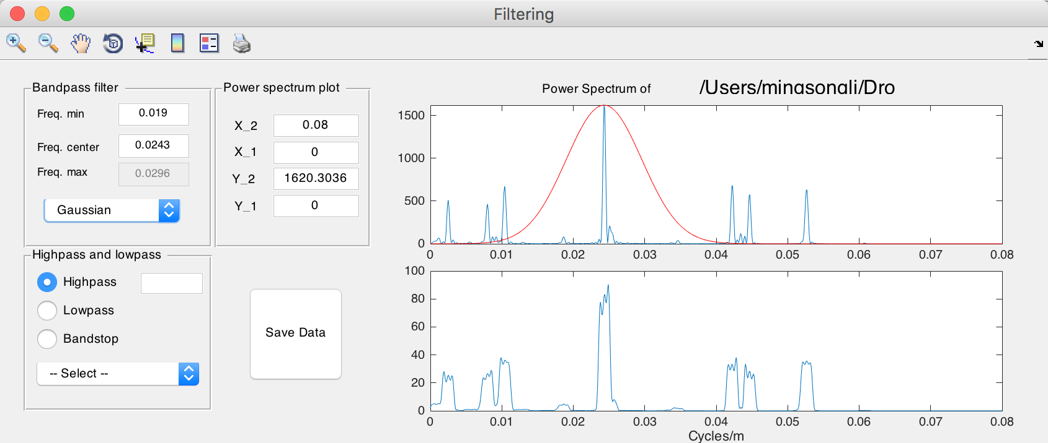

New file name: *-gaus-0.0243+-0.0053.csv, means filtered output series using gauss filter and a 0.0243 ± 0.0053 cycles/unit bandpass.

*-Tan-0.03+-0007.csv and *-Tan-0.03+-0007-AM.csv, mean filtered output series using Taner-Hilbert filter and a 0.03 ± 0.007 cycles/unit bandpass, with its amplitude modulation file saved.



*Original La2004 ETP solutions and filtered 41 kyr cycles*

### **Build Age Model**

This function generates an age model file from a filter output data file. Steps:

(1) Assuming the filtering wavelength generates a filtered 35 m cycle series. The 35 m cycles are assumed to be 405 kyr long eccentricity cycles. This filtered data file should be selected.

(2) Select **Timeseries** 🡪 **Build Age Model** menu

(3) In the pop-up window, enter 405 and 1, and click OK button. This generates a new age model series via assigning every peak of 35 m cycles as peaks of the 405 kyr cycles.

New file name: *-agemodel-405-max.csv,

means an age model file using filtered wavelength peaks as 405 kyr anchors.

### **Age Scale**

This function conducts depth-to-time transformation in a new standalone GUI. Steps:

(1) Select 1 (ONE) age model file, click the top ==> button to record this file as an age model file.

(2) Select 1 or more data files, click the bottom ==> button to record this file (these files) as series needs to be transformed.

(3) Click the OK button. The transformed series can be displayed and saved.

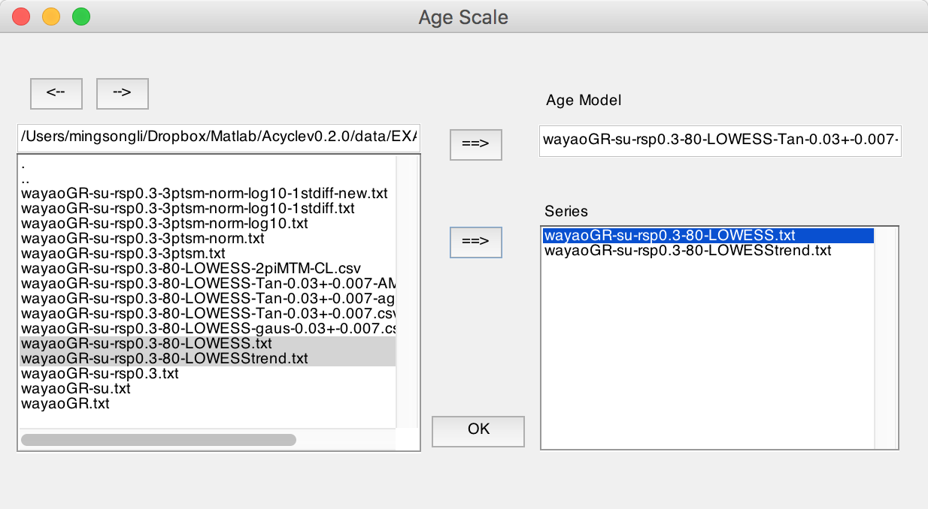

New file name(s): *-TD-name-of-agemodel-file.csv

*(Tips) Change directory using <-- or --> button*

### **Sedimentation Rate to Age Model**

Assuming you want to generate an age model file from a sedimentation rates file (2 columns: depth and sedimentation rate), this function generates an age model output that is compatible with other *Acycle* functions.

### **Power Decomposition Analysis**

This function subtracts power/variance within a user-defined frequency band. The code written by Mingsong Li and Linda Hinnov was published in Li et al. (2016). Time-dependent amplitude modulations in the obliquity component were obtained from 2π multi-taper variance (power) spectra calculated along a sliding time window using the Matlab script *pda.m* (also available at <https://doi.pangaea.de/10.1594/PANGAEA.859147)>. Steps:

(1) Select the original data file.

Warning: The data must be evenly spaced data in the first column. And the unit must be in kyr.

(1) Type paired frequency bands; space delimited. If a dominated frequency is 1/33, then a 1/45 1/25 frequency band is used

(2) Sliding window in kyr, a 500 kyr is used in Li et al. (2016)

(3) Time-bandwidth product, ‘2’ means 2π prolate tapers will be used.

(4) cutoff frequencies, min = 0, max should cover all Milankovitch frequencies.

### **Sedimentary Noise Model**

#### Dynamic noise after orbital tuning (DYNOT)

Dynamic noise after orbital tuning. Detect non-orbital variances from a tuned series. See **Chapter 5.** **DYNOT model Description**. See Li et al. (2018a) for details about this method.

#### Lag-1 autocorrelation coefficient (ρ1)

This function conducts either single run or Monte Carlo simulations of lag-1 autocorrelation coefficient (***ρ*1**) using a sliding window. It works with both depth series and time series.

The “Single run” requires the input of “window” and “interpolation sampling rate”.

The “Monte Carlo” requires several parameters: Number of Monte Carlo simulations (default is 1000), sliding window ranges from *win1* to *win2*, and a sampling rates from *sr1* to *sr2*, and plot settings (interpolation and shift grid).

See Li et al. (2018a) for details about the parameters and significance of this method.

### **Correlation Coefficient (COCO/eCOCO)**

This function addresses two fundamental issues in cyclostratigraphy and paleoclimatology: identification of astronomical forcing in sequences of stratigraphic cycles, and accurate evaluation of sedimentation rates. This technique considers these issues part of an inverse problem and estimates the product-moment correlation coefficient between the power spectra of astronomical solutions and paleoclimate proxy series across a range of test sedimentation rates. The number of contributing astronomical parameters in the estimate is also considered. This procedure tests the hypothesis that astronomical forcing had a significant impact on proxy records. The null hypothesis of no astronomical forcing is evaluated using a Monte Carlo simulation approach. Details are included in (Li et al., 2018c). This technique was inspired by the average spectral misfit procedure by Meyers and Sageman (2007), which is provided in the asm function of the *Astrochron* R Package.

Ensure the unit is selected as m. Note the data series must have units in “meter”.



Select a depth series (interpolated, detrended), select **Timeseries --> Correlation Coefficient (COCO/eCOCO)** menu

**Step 1: Select model**: COCO

**Step 2: Data: zero padding** (default value is usually enough).

***\* Show periodogram****. Max frequency is Nyquist frequency. This is for plot use only.*

**Step 3**: Split series: 1 (default), 2, 3. If a number of “2” is used, the series will be split into 2 or more slices.

**Step 4: Choose “remove red noise model”**

Unselect = no removing red noise (if the conventional AR1 noise model doesn’t fit to the power spectrum, COCO may not work. Therefore, remove noise = 0 might be a solution);

Else, removing red noise has **3 options**:

(1) classic AR1 [*f* = (Periodogram / Power of AR1 red noise) – 1, if *f*<0, *f* =0];

(2) classic AR1[ *f* = (Freq – Freq of AR1 red noise), if *f*<0, *f* =0] (**Default**, the best option for the time series with a “red” spectrum).

(3) Robust AR1 [*f* = (Freq – Freq of robust AR1 red noise), if *f*<0, *f* =0] (experimental).

**Step 5:** **Settings for test sedimentation rate**

Minimum sedimentation rate: This default value may represent the detection limit of COCO.

Maximum sedimentation rate: This default value may represent the detection limit of COCO.

Step sedimentation rate: tested sedimentation rates range from *fMIN* to *fMAX*, with a step of *STEP* cm/kyr. In the following example, the tested sed. rates are 4.29, 4.49, …, and 29.89 cm/kyr (129 test sedimentation rates).

  

**Step 6: Median age of data.** Type the approximate age for the depth series, the unit is million years ago (Ma).

**Step 7. Target frequency.** It ranges from 0 cycle/kyr to the given “MAX frequency”. Default values are recommended for the depth series with age less than 250 Ma.

For the depth series older than 250 Ma, the **MAX frequency will be set to 0.08**. This is because the precession cycle can be very short than 16 kyr.

**Step 8: Astronomical solution [optional]**

Three astronomical solutions are available:

1. Berger89 solution (Berger et al., 1989),

2. Laskar 2004 solution (Laskar et al., 2004),

3. User-defined solution. The input box should be filled by 7 astronomical periods.

Online resource for user-defined astronomical parameters may be found at <http://nm2.rhul.ac.uk/wp-content/uploads/2015/01/Milankovitch.html> (Waltham, 2015).

**Step 9: Correlation method [Default = Pearson]**

**Step 10: Number of Monte Carlo simulations.** 200-600 simulations are suggested for an initial run. And 2000 simulations generate publication quality results, however, 5000 or 10000 simulations will generate even better results.

**Step 11. Run.** Click the OK button, Monte Carlo simulation steps can be displayed in the Command Window of MatLab/Terminal. A log file will be generated recording all parameters used in the correlation coefficient analysis.



The optimal sedimentation rate is 8.1 cm/kyr (joint maxima of rho and H0-SL), which is comparable to the sedimentation rate of 8.6 cm/kyr estimated by Zhang et al. (2015).

**Evolutionary Correlation Coefficient (eCOCO)**

The method is applied using a sliding stratigraphic window to track variable sedimentation rates along the proxy series, in a procedure termed “eCOCO” (evolutionary correlation coefficient) analysis (Li et al., 2018c).

Warning: the data series must have units in “meter”.

**Step 1: Select model**: eCOCO

**Step 2: Data: zero padding** (default value is usually enough).

**Step 3**: **Zero padding edge**: This option will zero pad the data series at both ends. Resulted evolutionary COCO will show the missed half-window in a typical evolutionary COCO. This newly added option is to add back the missed half-window due to the sliding window methods. However, this might introduce incorrect estimation of sedimentation rate (for example, when a series with trend at one or both ends).

***\* Show periodogram****. Max frequency is Nyquist frequency. This is for plot use only.*

**Step 4: Choose “remove red noise model”**

Unselect = no removing red noise (if the conventional AR1 noise model doesn’t fit to the power spectrum, COCO may not work. Therefore, remove noise = 0 might be a solution);

Else, removing red noise has **3 options**:

(1) classic AR1 [*f* = (Periodogram / Power of AR1 red noise) – 1, if *f*<0, *f* =0];

(2) classic AR1[ *f* = (Freq – Freq of AR1 red noise), if *f*<0, *f* =0] (**Default**, the best option for the time series with a “red” spectrum).

(3) Robust AR1 [*f* = (Freq – Freq of robust AR1 red noise), if *f*<0, *f* =0] (experimental).

**Step 5:** **Settings for test sedimentation rate**

Minimum sedimentation rate: This default value may represent the detection limit of COCO.

Maximum sedimentation rate: This default value may represent the detection limit of COCO.

Step sedimentation rate: tested sedimentation rates range from *fMIN* to *fMAX*, with a step of *STEP* cm/kyr.

 

**Step 6: Median age of data series.** Type the approximate age for the depth series, the unit is million years ago (Ma).

**Step 7. Target frequency.** It ranges from 0 cycle/kyr to the given “MAX frequency”. Default values are recommended for the depth series with age less than 250 Ma.

For the depth series older than 250 Ma, the **MAX frequency will be set to 0.08**. This is because the precession cycle can be very short, ~16 kyr or shorter.

**Step 8: Astronomical solution [optional]**

Three astronomical solutions are available:

1. Berger89 solution (Berger et al., 1989),

2. Laskar 2004 solution (Laskar et al., 2004),

3. User-defined solution. The input box should be filled by 7 astronomical periods.

Online resource for user-defined astronomical parameters may be found at <http://nm2.rhul.ac.uk/wp-content/uploads/2015/01/Milankovitch.html> (Waltham, 2015).

**Step 9: Correlation method [Default = Pearson]**

**Step 10: Number of Monte Carlo simulations.** 200-600 simulations are suggested for an initial run. And 2000 simulations generate publication quality results, however, 5000 or 10000 simulations will generate even better results.

**Step 11: Running window (m) and step size**: default window is 35% of the total length of the data series.

Step size (m): sliding steps. The default value will give about ~300 sliding windows for publication quality results.

**Step 12. Run.** Click the OK button, Monte Carlo simulation steps can be displayed in the Command Window of MatLab/Terminal. A log file will be generated recording all parameters used in the evolutionary correlation coefficient analysis. The user needs to decide which figure output should be saved or not.



“eCOCO Plot” Button: User can plot eCOCO results any time after eCOCO results are shown.

**Q: Which window should I use?**

A: A window that covers 1.5-2 * long eccentricity cycles will give a reliable result. If your series is dominated by 35 m cycles (405 kyr, 8.6 cm/kyr), then a 52.5 m (= 35 * 1.5) - 70 m (= 35 * 2) window may be good to keep the balance: A large window eCOCO losses resolution of variable sedimentation rates, and a small window may not give correct results.

**Q: How do I know the sedimentation rate is 8.6 cm/kyr?**

A: COCO!

**Q: What is the additional plot when I use eCOCO?**

A: This additional plot is calculated using this equation:

rho * H0 = rho * (-1 * log10(H0-SL))

, where rho is the correlation coefficient as shown in the leftmost eCOCO figure; the H0-SL is the middle plot. For example, if a H0-SL = 0.003 (or 0.3%), and rho is 0.5, then -1*log10(0.003) = 2.523, rho * H0 = 0.5 * 2.523 = 1.26. This plot is to combine information from both eCOCO and eH0-SL to highlight the optimal sedimentation rate. It might help users identify the best sedimentation rate easily when individual eCOCO or eH0-SL plot is not clear.

### **TimeOpt**

TimeOpt determines the optimal sedimentation rate of a proxy data series, that has recorded an astronomical signal (Meyers, 2015). The function is based on the TimeOpt R code in *Astrochron* (<https://cran.r-project.org/package=astrochron>). For a “test” sedimentation rate, the TimeOpt method extracts the precession-band amplitude envelope from the proxy data and evaluates the first correlation coefficient (r2envolope) between this envelope and reconstructed eccentricity model. It also evaluates a second correlation coefficient (r2power) between the reconstructed astronomical (eccentricity and precession) model series and the time-calibrated proxy series. Finally, a measure of fit (r2opt) combine both correlation coefficients using an equation: r2opt = r2envolope* r2power. Monte Carlo simulation with a first-order autoregressive model is used to determine the statistical significance of the observed r2opt value. For advanced applications of TimeOpt, the user is referred to Meyers, 2019, and *Astrochron 1.0* (<https://cran.r-project.org/package=astrochron> ).

**Step 0**: Select a time series in depth domain (interpolation is needed if the sampling rate is non-uniform).

**Warning**: the unit of depth-series should be in “meter”.

**Step 1**: In the pop-up window, set the test sedimentation rate:

linear or log model?

Minimum, maximum, and step of sedimentation rates. (Default values are usually okay)

**Step 2**: Set the median age of the data series OR type frequencies of eccentricity and precession.

You will only need to give the median age of the data series; the frequencies will be calculated automatically from the La2004 astronomical solution.

The Taner bandpass cut-off frequencies are also adjusted automatically.

If the median age is > 249 Ma, you may type the frequencies.

**Step 3**: Fit to precession modulations (default), and short-eccentricity modulation may not be reliable.

**Step 4**: If you have typed the frequencies in Step 2, you will also need to adjust frequencies here.

**Step 5**: Simulations are to evaluate the null hypothesis of the optimal sedimentation rate. This can be very time-consuming.



### **eTimeOpt**

evolutive TimeOpt method (Meyers, 2019).

**Step 0**: Select a time series in depth domain (interpolation may be needed if the sampling rate is un-even). For an example, select “Basic Series” 🡪 “Examples” 🡪 “Late Triassic Wayao gamma ray” 🡪 select generated text file entitled “Example-WayaoCarnianGR0.txt” in the *Acycle* main window.

**Step 1**: In the pop-up window, set the test sedimentation rate:

linear or log model?

Minimum, maximum, and the step of sedimentation rates.

**Step 2**: **Set the median age of data** OR enter frequencies of eccentricity and precession.

You’ll only need to give the median age of the data; the frequencies will be calculated automatically from an astronomical solution of La2004.

If the median age is > 249 Ma, enter the frequencies.

**Step 3**: **Set filter.** Fit to precession modulations (default); short-eccentricity modulations may not be reliable.

The Taner bandpass cut-off frequencies are also adjusted automatically.

**Step 4**: Set the sliding window and step. Default window size is 35% of total range of depth. This should be adjusted, a window size of 1.5 - 2 x (405-kyr related wavelength) is usually good enough. Default step size usually generate ~200 sliding window, this is sufficient to generate a publication quality eTimeOpt result.

**Step 5**: You may select to normalize each sliding window (forcing the maxima values of each window to 1). Ticking “Flip Y-axis” checkbox will flip y-axis.

**Step 6**: Click OK button to run the eTimeOpt.



You will have following new MatLab figure files, with eTimeOpt outputs.





### **Spectral Moments**

*This section is from the Manual for the Spectral Moments by* Sinnesael et al. (2018)*.*

*Q: What is meant by 'Spectral Moments'?*

*A: Mathematically speaking, moments are unique quantities describing a specific set of points. For example, in mechanics, the moments can describe the distribution of mass in a system. In statistics, the set of points can represent probability densities. For instance, for the commonly used normal distribution one would characterize its distribution by the mean (first moment), the variance (second moment) and so on. In the case of spectral moments, we apply the concept of moments on the spectral distribution of a signal (i.e. in this study a periodogram).*

*Q: OK, but how could this work practically?*

*The basic approach in this study is to calculate the spectral moments (here: mean frequency - first moment and bandwidth - second moment) over a data record using a moving window approach. This means that changes in the whole spectrum characteristics are evaluated over the record. Here we use simple periodograms as spectra to calculate the first two moments from for the data in a certain window. Then this window is moved by a certain step and the calculations are done again... this till the end of the record is reached where after all calculations over the record are combined using an overlap-add approach. This procedure gives the change of the spectral moments over the record and provides information on changing characteristcs of your signal. We included also the option to take the trend of the change of a spectral moment over the record and optionally couple this to a certain frequency (e.g. astronomical component) in the case that the hypothesis is that the changes in (astronomical) frequencies over a record are due to changing sedimentation rates.*

**Data requirement:**

DATA MUST BE UNIFORMLY SAMPLED!!!

If your original data is not, we suggest interpolation before using of this routine.



**Step 1:** Select Uniformly sampled depth scale dataset in *Acycle* main window (*.txt file).

**Step 2:** Select “Time Series” – “Spectral Moments” tool.

**Step 3:** **Zero padding edge**: This option will zero pad the data series at both ends. Resulted plots will show the missed half-window due to a typical sliding window procedure. However, this might introduce incorrect estimation of sedimentation rate at both ends (for example, when a series with trend at one or both ends). Options for padding edge include “zero” (= add 0 values), “mirror” (= copy both ends of data), “mean” (= mean of the dataset), and “random” (= random numbers).

**Step 4:** **Window size**. May be 1-2 times of 405-kyr cycle related wavelength. For example, if the mean sedimentation rate (based on COCO/TimeOpt) is 8.5 cm/kyr, the 405 kyr cycles may correspond to 34.4 m. Here a 45 m window size is used.

*For more elaborations on the use and choice of window size, selecting component frequencies, we refer to the chapter '2.3 Practical considerations' in Sinnesael et al., 2016, Astronomical component estimation (ACE v.1) by time-variant sinusoidal modeling published in the open-access journal of Geoscientific Model Development:* [*https://www.geosci-model-dev.net/9/3517/2016/gmd-9-3517-2016.html*](https://www.geosci-model-dev.net/9/3517/2016/gmd-9-3517-2016.html)

**Step 5:** Step. Default value is the sampling rate.

**Step 6:** zero padding: zero padding for each sliding window (default value is usually good).

**Step 7:** Absolute sedimentation rate. This rate will be used to transform the relative sedimentation rate from the Spectral Moments to the absolute sedimentation rate. The final absolute sedimentation rate will be forced to be the number you set.

*Q: How do I set this sedimentation rate?*

*A: Try COCO and TimeOpt to get the mean optimal sedimentation rate.*

**Step 8:** Smooth model: Default model is “Polynomial” model. It will evaluate the polynomial trending (using a moving frame size) of the signal. Other options include MatLab’s LOWESS, rLOWESS, LOESS, and rLOESS models.

**Step 9.** OK. Click OK button to run the spectral moments. This can take a couple of minutes (or even longer!!) if the dataset has over thousands of data points.



Spectral moments of the detrended Wayao GR data.

The bottom figure shows the sedimentation rate changes from 11 cm/kyr to 6 cm/kyr through the series, which is comparable to the eCOCO generated sedimentation rate map in the “Evolutionary Correlation Coefficient (eCOCO)” section of this Users’ Guide.

## **4.8 Help**

### **What’s New**

Show update log file / online document

### **Manuals**

Open the <User’s Guide> document

[https://github.com/mingsongli/*Acycle*/wiki](https://github.com/mingsongli/acycle/wiki)

### **Find Updates**

Visit websites to find updates of *Acycle* software.

[www.mingsongli.com/*Acycle*](http://www.mingsongli.com/acycle)

[https://github.com/mingsongli/*Acycle*](https://github.com/mingsongli/acycle)

### **Copyright**

Show copyright GUI.

### **Contact**

## **4.9 Mini-robot**

This tool can do some work automatically with default settings.

Step 1: Click to select one data file (see **3.6 Data Requirement**) in the *Acycle* main window.

Step 2: Click the mini-robot button.

Step 3: review parameters and click the “OK” button.

 

**It will do:**

1. Data preparation - check selected data: **remove NaN** numbers, **remove empty** values, **sort** data (based on the first column), remove duplicated numbers (“**Unique**”, replace with their mean value).

2. Interpolation: using the **mean**/median/max/min/user-defined sampling rate

3. Detrending: removing a long-term trend using users defined parameters (default value is 35% LOWESS).

4. Power spectral analysis: to show significant frequencies; aided with a robust AR(1) red noise model using a log best-fit to the 25% median-smoothed spectrum.

5. Evolutionary FFT: using an adjusted sliding window.

6. Wavelet transform: using settings of user-defined period range.

7. Save results.

8. Pause 0.5 seconds after each above step.

# **5. DYNOT model Description**

Li et al. (2018a) *developed a dynamic noise after orbital tuning, or DYNOT model for the*

*sea-level changes based on the dynamic non-orbital signal in climate proxy records after subtracting orbital, i.e., astronomically forced climate signal. The DYNOT model is*

*supplemented by a second, independent lag-1 autocorrelation coefficient, or ρ1 model, which forms the basis of a statistical method for red noise estimation of time series. DYNOT and ρ1 modeling of a GR series of ODP Site 1119 over the past 1.4 myr correlates with the classic low-passed δ18O sea-level curve, demonstrating the efficacy of the sedimentary noise model.*

## **5.1 Data format**

*data for the DYNOT model (support data in *.csv and *.txt format)*

Name: data

Length: m × 2 % must be a 2-column dataset

Column 1: time % unit must be in ka;

Column 2: value

**Notes**:

**#1:** Proxy data is assumed to be sensitive to water-depth related noise at your section/core.

**#2:** There is no requirement for interpolation, normalization, or removing long-term trend (i.e., pre-whitening) of the dataset.

**#3:** Extreme values should be removed.

**#4:** Both increasing-upward and decreasing-upward time series are valid.

## **5.2 Startup**

1. Left click to select a dataset file in *Acycle* main window.

2. Select“Timeseries” – “Sedimentary Noise Model” – “DYNOT”

3. The DYNOT sea-level model GUI (Fig. 2) is below.



Fig. 1. MatLab workspace for the DYNOT model.



Fig. 2. The DYNOT model

**4. Click Data ready button load data** or load data ***from *.txt or *.csv file***

In the DYNOT menu: Select “File” 🡪 “Import Data (*.txt, *.csv) ” 🡪 Select data (chose “1119_gr_1400de_finetuned.txt” or “1119_gr_1400de_finetuned.csv”) 🡪 Click “Open ”



Fig. 3. Load data to DYNOT model.

## **5.3 Settings**

*Yellow: load data and run the model.*

*Red: Key settings. Check before running the model.*

*Green: Optional settings. Default values are okay for most running.*

5.3.0. Click on Data ready (button) to load data into the DYNOT model.

5.3.1. Cut data (*optional*): These settings automatically show the beginning and the end of the time series, i.e., time span of dataset. Unit is ka. If you want to choose a different interval, just type two new ages and click Cut button.

5.3.2. Sampling rates (*optional*): These show a range of sample rates covering 90% of sample rates (Green Box 20 in Fig. 4). Unit is ka. A Monte Carlo method of hypothesis testing and the multi-taper method (MTM) of power spectral analysis will be undertaken, and so resampling must be applied. Sampling rates of proxy datasets in time are always greater than zero and so are non-normally distributed. Therefore, the Weibull distribution is used to represent sampling rate distributions for uncertainty analysis in the DYNOT model. To avoid an ultra-low or ultra-high, unrealistic sampling rate created by the Weibull distribution algorithm, we set the 5th and 95th percentiles of sampling rates of of the data as default, lower and upper limits of the generated, Weibull-distributed sampling rates.

5.3.3. **Windows**: These values set sliding window range. Moving window length in units of time (<< total data length). Unit is ka.

Different windows in the DYNOT model can affect results in two ways.

(1) The DYNOT model with a large window will shorten DYNOT results, and the model with a small window will generate longer DYNOT results, *Nr* = *Ndata* – *window* + 1, where *Nr* is total number of DYNOT values of each simulation, *Ndata* is total number of interpolated data points, and *window* is the running window employed.

(2) The DYNOT model with a small running window generates higher resolution results, however, the variance of low-frequency cycles and total variance diminish simultaneously, which leads to increased uncertainty in non-orbital signal ratio estimation.

The DYNOT model with a small running window also increases the MTM power spectrum bandwidth (i.e., reduces frequency resolution). The expected sea-level variations of interest in the Early Triassic are 104 to 106 year-scale, i.e., the fifth to third-order sequences, therefore a comparable or shorter time window (e.g., 300-500 kyr, 400 kyr or shorter) should be adopted for DYNOT modeling.

5.3.4. Time-bandwidth product (*optional*): Time-bandwidth product of discrete prolate spheroidal sequences used for window. Typical choices are 2, 5/2, 3, 7/2, 4.

5.3.5. Zero-padding (*optional*). zero-padding number, e.g., 1000.

5.3.6. Step (*optional*). step of calculations; default is 5 ka.

5.3.7. **Number of Monte Carlo Simulations:** default is 1000. Maybe use 100 or 300 for a trial running. Recommended value for publication is >5000.

5.3.8. **Age of the time series**: The age in Ma will be used to estimated target orbital cycles in 5.3.9. You can use either 5.3.8 or 5.3.9 to tell the DYNOT model the target cycles.

5.3.9. **Target orbital cycles** (space delimited, in ka): 6 orbital cycles of long-eccentricity (405), short-eccentricity (125 and 95), obliquity (40.9 or shorter), precession (23.6, 22.3, and 19.1 or shorter). This is age dependent (see 7.8). The 405, 125, and 95 kyr cycles are assumed to be invariant through time. While the obliquity = 41-0.0332*age; precession 1 = 23.75-0.0121*age; precession 2 = 22.43-0.0121*age; precession 3=19.18-0.0079*age. These calculations are from Yao et al. (2015), and are based on the La2004 astronomical model (Laskar et al., 2004).



Fig. 4. Settings of the DYNOT model.

*Yellow: load data and run the model.*

*Red: Key settings. Check before running the model.*

*Green: Optional settings. Default values are okay for most running.*

5.3.10. Frequency ranges (*optional*): For the definition of the non-orbital signal ratio by Li et al. (2018a), cutoff frequencies and their bandwidths are crucial for estimation of variances of eccentricity, obliquity and precession signals. We vary each cutoff frequency assuming a uniform distribution with cutoff frequency ranges at ± 90% to ± 120% bandwidth. Here the bandwidth (*bw*) equals *nw*/*window*, where *nw* is time-bandwidth product of discrete prolate spheroidal sequences, and *window* is the running window.

5.3.11. Cutoff frequencies (*optional*): lower cutoff frequency (> 0) for estimation of total variance and upper cutoff frequency (< Nyquist frequency) for estimation of total variance.

5.3.12. Confidence levels (*optional*): default values show median and confidence levels (e.g., 50%, 68%, 80%, 90%, and 95%) of the DYNOT results.

5.3.13. Interpolation (*optional*): In 5.3.3, a smaller *Nr* compared to *Ndata* leads to a “no data” effect at the very beginning and/or very end of the DYNOT results. To avoid this problem and to provide a better constraint for noise estimation, technically, the DYNOT model is interpolated and randomly shifts and plots simulation results of a single iteration at the same time scale of the dataset, although the plots also generate relatively smoothed DYNOT spectra when a gap is shorter than 2 × *window*. Here 1000 is adequate for the DYNOT model.

5.3.14 Shift plot grids (*optional*): See 5.3.13 for interpretation. Default is 15. One can also use 15-30 for the better shape of the beginning and the end of the DYNOT spectra.

5.3.15. Number of physical cores (*optional*): This detects the physical cores of the CPU of the computer.

5.3.16. Number of itineraries to estimate the process time (*optional*): To estimate process time of the time-consuming DYNOT model, the model will run some itineraries. Default is 50.

5.3.17. Emergency note: Press “Ctrl” + “C” to cease the DYNOT process before the parallel computing. Press “Ctrl” + “X” to cease the DYNOT process during the parallel computing. You may need to type the following script in the command window to quite parallel computing.

>> delete(gcp(‘nocreate’))

5.3.18. Click the button to run the model.

5.3.19. A window shows the dataset.

5.3.20. A window shows sample rates of the dataset OR the DYNOT spectrum of the dataset.

## **5.4. Running the DYNOT model**

Click the Let’s go button to run the DYNOT script. In the command window, the estimated running time will appear:

16:21:20 Begin the process ...

16:22:54 First 50 iterations suggest: remain >= 0h:7m:27sec

% The model runs the first 50 iterations to estimate that the total running time will last ca. 7 minutes 27 seconds. The real run-time may be 10s seconds to several minutes longer than this estimate.

Starting parallel pool (parpool) using the 'local' profile ... connected to 4 workers.

16:23:07 Current iteration takes 1.11 seconds

16:23:08 Current iteration takes 1.21 seconds

16:23:15 Current iteration takes 1.19 seconds

16:26:26 Current iteration takes 1.38 seconds

% Start parallel computing and show time of each iteration.

Parallel pool using the 'local' profile is shutting down.

>> Done. % Stop parallel computing and display the DYNOT result (Fig. 5).



Fig. 5. DYNOT sea-level model of the gamma-ray series at ODP site 1119 from 0 to 1.4 Ma.

## **5.5. Output Files**

After running the DYNOT model, the median value of noise and percentiles of the outputs will be saved as text files.

The GUI menu (Fig. 6) can be used to:

#1: save a MatLab-fig in the working directory entitled “plots_.fig”.

#2: save a PDF file of the plots in the working directory entitled “plots_.pdf”

#3: pop-up display the DYNOT spectrum in a new window.

#4: save DYNOT output data in the working directory entitled “result_handles.mat”.

**Caution: Change names of output files, or they will be overwritten by new files.**



Fig. 6. Output files

# **6. Case Studies**

## **Typical procedures in cyclostratigraphy**

[https://github.com/mingsongli/*Acycle*/wiki#typical-procedures](https://github.com/mingsongli/acycle/wiki#typical-procedures)

The identification of potential astronomical signals in paleoclimate data series using Acycle involves the following steps:

1. Users must formulate the data in an [input format accepted by Acycle](https://github.com/mingsongli/acycle/wiki/3.-Getting-Started#36-data-requirement) ([examples](https://github.com/mingsongli/acycle/wiki/4.5-Basic-Series#examples)).
2. Original data may need [sorting, removing empty values, or averaging multiple values](https://github.com/mingsongli/acycle/wiki/4.6-Math#sortuniquedelete-empty) assigned to the same depth (time).
3. The data must be [interpolated](https://github.com/mingsongli/acycle/wiki/4.6-Math#interpolation) to a uniform sampling interval ([example](https://github.com/mingsongli/acycle/wiki/Examples#step-3-interpolation)).
4. [Detrending](https://github.com/mingsongli/acycle/wiki/4.7.1-Detrending) is usually useful ([example](https://github.com/mingsongli/acycle/wiki/Examples#step-4-detrending)).
5. [Power spectral analysis](https://github.com/mingsongli/acycle/wiki/4.7.3-Spectral-Analysis) is used to identify dominant frequencies. Fitting a [red noise model](https://github.com/mingsongli/acycle/wiki/4.7.3-Spectral-Analysis#6-red-noise-panel) to the background spectrum can help to determine which spectral peaks are significantly different from noise ([example](https://github.com/mingsongli/acycle/wiki/Examples#step-5-power-spectral-analysis)).
6. Users may need [evolutionary power spectral analysis](https://github.com/mingsongli/acycle/wiki/4.7.4-Evolutionary-Spectral-Analysis) ([example](https://github.com/mingsongli/acycle/wiki/Examples#step-5-evolutionary-spectral-analysis-1)) for inspecting changes in frequency patterns through the data series.
7. A method that applies a [correlation coefficient approach](https://github.com/mingsongli/acycle/wiki/4.7.12-Correlation-Coefficient-(COCO)) jointly determines optimal sedimentation rate and tests the null hypothesis that no Milankovitch frequency is present in the data ([example](https://github.com/mingsongli/acycle/wiki/Examples#step-7-correlation-coefficient)).
8. Based on the wavelengths (stratigraphic thicknesses) of prominent cycles in a stratigraphic data series, and an assumed sedimentation rate, [filtering tools](https://github.com/mingsongli/acycle/wiki/4.7.6-Filtering) may be applied to isolate specific frequency bands ([example](https://github.com/mingsongli/acycle/wiki/Examples#step-8-filtering)).
9. Stratigraphic data series may be correlated/tuned using the [“Age Scale”](https://github.com/mingsongli/acycle/wiki/4.7.8-Age-Scale) function in Acycle based on the astronomical cycles inferred from filtering ([example](https://github.com/mingsongli/acycle/wiki/Examples#step-9-age-model-and-tuning)).
10. Other approaches are provided to decipher hidden information in the data, for example, a [sedimentary noise model](https://github.com/mingsongli/acycle/wiki/4.7.11-Sedimentary-noise-model) for stratigraphic data from marginal marine successions that are linked to [sea level changes](https://www.nature.com/articles/s41467-018-03454-y).

**Steps 3-10** are commonly time-consuming, and **Steps 2-6** can be done automatically with a “mini-robot” imbedded in Acycle.

Next page: Flowchart of cyclostratigraphic analysis in ***Acycle*** software

**

## **Example #1: Insolation**

**Data**: Insolation at 65°N on June 22 over the past 2 million years

**Age**: 0-2000 Ka

**Proxy**: Insolation.

**Target**:

You will find the dominant cycles of insolation in the past 2 million years

**Tool:**

*Acycle* software (<https://github.com/mingsongli/acycle>)

**References**:

Berger A.L., 1978. A simple algorithm to compute long term variations of daily or monthly insolation. Contribution No. 18, Institut d’Astronomie et de Géophysique Georges Lemaître, Université Catholique de Louvain, Louvain-la-Neuve, Belgique, 17 p.

Laskar, J., Robutel, P., Joutel, F., Gastineau, M., Correia, A.C.M., Levrard, B., 2004. A long-term numerical solution for the insolation quantities of the Earth. Astronomy & Astrophysics 428, 261-285.

### **Step 1: Load data**



You will have the following data and figure.



### **Step 2: Data pre-processing**

 

Since the data is not in ascending order. Here we’ll need sort data first.

### **Step 3: Detrending**

Remove the mean value of the insolation series.





You will have:



### **Step 4: Power Spectral Analysis**



Using the following settings:

 

Three peaks in the 2π (@Num.tapers) MTM (multi-taper method) power spectrum are 1/0.04218 = 23.7 kyr, 1/0.04468 = 22.4 kyr, and 1/0.05267 = 19.0 kyr.

### **Step 4: Evolutionary Spectral Analysis**







This series is dominated by precession cycles. And clearly 405-kyr modulation can be seen in the evolutionary fast Fourier transform (blue arrows).

## **Example #2: La2004 astronomical solution (ETP)**

**Data**: La2004 ETP over the past 2 million years

**Age**: 0-2000 ka

**Formulating ETP**:

Laskar et al. (2004) astronomical solutions of Eccentricity, Tilt (obliquity), and Precession, or may be formulated as ETP as follows:

ETP = standardized E + standardized T - standardized P

, where standardized E = (E – mean(E))/ standard deviation of E (same for T and P)

**Target**:

Dominant frequencies of the ETP series

**Tool:**

*Acycle* software (<https://github.com/mingsongli/acycle>)

**Reference**:

Laskar, J., Robutel, P., Joutel, F., Gastineau, M., Correia, A.C.M., Levrard, B., 2004. A long-term numerical solution for the insolation quantities of the Earth. Astronomy & Astrophysics 428, 261-285.

### **Step 1: Load data**



You will have:



### **Step 2: Data pre-processing**

Since the data is not in ascending order. Here we’ll need sort data first.

 

### **Step 3: Detrending**

Remove the mean value of the insolation series.





### **Step 4: Power Spectral Analysis**

Using the following settings:

Seven peaks in the 2π (@Num.tapers) MTM (multi-taper method) power spectrum are 405 kyr, 125 kyr, 95 kyr, 41 kyr, 23.7 kyr, 22.4 kyr, and 19.0 kyr.





### **Step 5: Evolutionary Spectral Analysis**







This series is dominated by 405 kyr long eccentricity, ~100 kyr short eccentricity, 41 kyr obliquity, 22 kyr and 19 kyr precession cycles.

### **Step 6: Wavelet transform**

Using the following settings:

 



## **Example #3: Carnian cyclostratigraphy**

**Section**: Wayao section, Guizhou, South China

**Age**: middle Carnian

**Lithology**: The limestone beds of the Zhuganpo Formation displays patterns of variable bed thicknesses and changing clay content within the limestones as reflected in relative weathering resistance.

**Proxy**: These factors influence the natural gamma-ray signal with higher intensities indicating higher average clay contents.

**Target**:

You will learn typical data process steps in cyclostratigraphy.

**Tool:**

*Acycle* software (<https://github.com/mingsongli/acycle>).

**Reference**:

Zhang, Y., Li, M., Ogg, J.G., Montgomery, P., Huang, C., Chen, Z.-Q., Shi, Z., Enos, P., Lehrmann, D.J., 2015. Cycle-calibrated Magnetostratigraphy of middle Carnian from South China: Implications for Late Triassic Time Scale and Termination of the Yangtze Platform. Palaeogeography, Palaeoclimatology, Palaeoecology 436, 135-166.

### **Step 1. Load Data**

Select: Basic Series 🡪 Examples 🡪 Late Triassic Wayao gamma ray.

The gamma ray data entitled “Example-WayaoCarnianGR0.txt” will be loaded and displayed in the *Acycle* main window.



Left click to select the data file and select Plot 🡪 Plot to plot the data. Double click the data file to see the accepted format of *Acycle* software.



### **Step 2. Data Preparation**

*Acycle* includes several toolboxes to facilitate data preparation. Users can sort data in ascending order. Two or more values for the same time (or depth) may be averaged with the "Unique" function.



### **Step 3. Interpolation**

Stratigraphic depth or time series are typically irregularly spaced due to uncertain timescales or difficulty in data collection. This necessitates interpolation to generate uniformly spaced time (or depth) series.

Let’s look at the sampling rate plot first.

Select Plot 🡪 Sampling Rate.



You’ll see the sampling intervals of gamma ray data are irregularly spaced with a median of 0.3333 and mean of 0.35341 (up right corner of figures below). 

Math 🡪 Interpolation (or Ctrl + I). Then type the new sampling rate to interpolate.

 

With a 0.33 m as a new sampling rate, *Acycle* will generate a uniformly-spaced file entitled:

“Example-WayaoCarnianGR0-rsp0.33.txt”.

### **Step 4. Detrending**

Detrending is a key step in time series analysis. Removal of these long-term trends, or detrending, is a critical step for power spectral analysis to ensure that data variability oscillates about a zero mean, and to avoid power leakage from very low-frequency components into higher frequencies of the spectrum.



Select the file; then select Timeseries 🡪 Detrending (or CTRL + T).

In the pop-up window, select window size, detrending method. Then click OK to see the various trending.

Don’t close “*Acycle*: Detrending” window or “New figure” window. Now change window size in the left panel, you will see the response in the right panel.



You will need to Select & Save detrending Model. I will choose an 80-m LOWESS trend for the best fit of the data without removing too many cycles.

The *Acycle* main window now displays an “Example-WayaoCarnianGR0-rsp0.33-80-LOWESS.txt” detrended file and a “***-LOWESStrend.txt” trend file.



### **Step 5. Power spectral analysis**

Power spectral analysis has become a cornerstone in paleoclimatology and cyclostratigraphy. Power spectral analysis evaluates the distribution of time series variance (power) as a function of frequency. The primary use of power spectral analysis is for the recognition of periodic or quasi-periodic components in a data series

Select the detrended file and choose “TimeSeries” 🡪 “Spectral Analysis”



Then choose Multi-taper method (MTM) with robust AR (1) red noise models.

**Use the following setting:**

2 pi MTM with a 5 times zero-padding (to increase frequency resolution).

The maximum frequency set to 1 cycle/m and use a linear Y plot.

Testing with a robust AR1 red noise model, then (right panel) using a 20% median smoothing window and fitting to a log power of spectrum power.



You will have the MTM power spectrum with red noise models.

Remember the period of a given cycle (frequency peak) is 1/frequency. For example, the highest frequency peak (middle value) is 0.02951 cycles/m. The corresponding cycle is 1/0.02951 = 33.9 m.



2π MTM power spectrum of the gamma ray series is shown with 20% median-smoothed spectrum, background AR(1) model, and 90%, 95%, 99%, and 99.9% confidence levels.

*[If you count all peaks higher than 95% confidence levels, you will find the 33.9 m, 10 m, 7 m, 2.6 m, and 1.8 m cycles. The ratios of these cycles are 405 kyr, 119 kyr, 83 kyr, 31 kyr, and 21.5 kyr cycles].*

### **Step 6. Evolutionary power spectral analysis**

Select data and then select “TimeSeries” 🡪 Evolutionary Spectral Analysis



Use the following settings.

A sliding window of 40 m *(Why? The longest cycle is 33.9 m, this window should be larger than 33.9 m. A 1.5-2 times of 33.9 m is good enough)*.

The maximum frequency is 0.7, this is to highlight low-frequency power.

Normalize each window: make spectral peaks in each window to be 1.

Flip Y-axis: because the first column of this data is increasing upward.

Then click ok to show results.



Don’t close these two windows. Now, you may change frequency limit, flip Y-axis, change colormap to change the left window.

This figure tells me the dominated cycles of ~34 m is stable in frequency (period). Therefore, the sedimentation rate is probably not variable (too much).

### **Step 7. Correlation coefficient**

To estimate the most likely sedimentation rate. Select the detrended data, then click “Timeseries” 🡪 Correlation coefficient.



Tell COCO the median age of your data (~230 Ma). It doesn’t matter if this age has an uncertainty, an uncertainty of less than 2-5 Myr is acceptable.

Set up the test sedimentation rate range (default values are used here).

.

Monte Carlo simulation: the number is 1000 (or 500) for an initial test. A 2000 (or more) number is recommended for a publication purpose.

Split series: If the data set is very long, “Number of slices” may use 2 or 3.



You will have the following figure and a log file saving all settings:

It indicates the most likely sedimentation rate as ~8.1 cm/kyr, with a confidence level of 0.1%. All seven orbital parameters are used in the estimation.





Now using a 45 m window eCOCO analysis to track variable sedimentation rate.





### **Step 8. Filtering**

Filters are essential tools to aid in the isolation of specific frequency components in a data series.

Select data, then “Timeseries” 🡪 Filtering



In the pop-up window:

Select the center frequency, low frequency. Then select the Gaussian method. And “save data” button.



You will see the filtered series and data in the *Acycle* main window.





### **Step 9. Age model and tuning**

“Age Scale” toolbox in *Acycle* is useful to transform original data (usually in the depth domain) to tuned data (usually in the time domain) when an age model file is available.

Assuming these 33.4 m cycles are 405 kyr cycles

Select “Example-WayaoCarnianGR0-rsp0.33-80-LOWESS-gaus-0.028+-0.006.txt”

And then Timeseries 🡪 Build Age Model





Click OK, you will have an Age Model file:

Example-WayaoCarnianGR0-rsp0.33-80-LOWESS-gaus-0.028+-0.006-agemod-405-max.txt

Timeseries 🡪 Age Scale

Select the age model file

And select files to be tuned, click OK.



Tuned data will be ready.

“Example-WayaoCarnianGR0-TD-Example-WayaoCarnianGR0-rsp0.33-80-LOWESS-gaus-0.028+-0.006-agemod-405-max.txt”



### **Step 10. Repeat steps.**

You can repeat Steps 3-6 and Step 8.

# **References**

Berger, A., Loutre, M., Dehant, V., 1989. Influence of the changing lunar orbit on the astronomical frequencies of pre‐Quaternary insolation patterns. Paleoceanography 4, 555-564.

Charles, A.J., Condon, D.J., Harding, I.C., Pälike, H., Marshall, J.E.A., Cui, Y., Kump, L., Croudace, I.W., 2011. Constraints on the numerical age of the Paleocene-Eocene boundary. Geochemistry, Geophysics, Geosystems, 12(6), <https://doi.org/10.1029/2010GC003426>.

Husson, D., 2014. MathWorks File Exchange: RedNoise_ConfidenceLevels, <http://www.mathworks.com/matlabcentral/fileexchange/45539-rednoise-confidencelevels/content/RedNoise_ConfidenceLevels/RedConf.m>.

Kodama, K.P., Hinnov, L., 2015. Rock Magnetic Cyclostratigraphy. Wiley-Blackwell.

Laskar, J., Fienga, A., Gastineau, M., Manche, H., 2011. La2010: a new orbital solution for the long-term motion of the Earth. Astron Astrophys 532.

Laskar, J., Robutel, P., Joutel, F., Gastineau, M., Correia, A.C.M., Levrard, B., 2004. A long-term numerical solution for the insolation quantities of the Earth. Astron Astrophys 428, 261-285.

Li, M., Hinnov, L.A., Huang, C., Ogg, J.G., 2018a. Sedimentary noise and sea levels linked to land–ocean water exchange and obliquity forcing. Nature Communications 9, 1004.

Li, M., Huang, C., Hinnov, L., Chen, W., Ogg, J., Tian, W., 2018b. Astrochronology of the Anisian stage (Middle Triassic) at the Guandao reference section, South China. Earth and Planetary Science Letters 482, 591-606.

Li, M., Huang, C., Hinnov, L., Ogg, J., Chen, Z.-Q., Zhang, Y., 2016. Obliquity-forced climate during the Early Triassic hothouse in China. Geology 44, 623-626.

Li, M., Kump, L.R., Hinnov, L.A., Mann, M.E., 2018c. Tracking variable sedimentation rates and astronomical forcing in Phanerozoic paleoclimate proxy series with evolutionary correlation coefficients and hypothesis testing. Earth and Planetary Science Letters 501, 165-179.

Lisiecki, L.E., Raymo, M.E., 2005. A Pliocene‐Pleistocene stack of 57 globally distributed benthic δ18O records. Paleoceanography 20.

Lomb, N.R., 1976. Least-squares frequency analysis of unequally spaced data. Astrophysics and Space Science 39, 447-462.

Mann, M.E., Lees, J.M., 1996. Robust estimation of background noise and signal detection in climatic time series. Climatic Change 33, 409-445.

Meyers, S.R., Sageman, B.B., 2007. Quantification of deep-time orbital forcing by average spectral misfit. American Journal of Science, 307, 773-792.

Meyers, S.R., 2014. astrochron: An R Package for Astrochronology. <http://cran.r-project.org/package=astrochron>.

Meyers, S.R., 2015. The evaluation of eccentricity‐related amplitude modulation and bundling in paleoclimate data: An inverse approach for astrochronologic testing and time scale optimization. Paleoceanography, 30.

Meyers, S.R., 2019. Cyclostratigraphy and the problem of astrochronologic testing. Earth-Sci Rev 190, 190-223.

Olsen, P.E., Kent, D.V., 1996. Milankovitch climate forcing in the tropics of Pangaea during the Late Triassic. Palaeogeography, Palaeoclimatology, Palaeoecology 122, 1-26.

Paillard, D., Labeyrie, L., Yiou, P., 1996. Macintosh program performs time‐series analysis. Eos, Transactions American Geophysical Union 77, 379-379.

Scargle, J.D., 1982. Studies in astronomical time series analysis. II-Statistical aspects of spectral analysis of unevenly spaced data. The Astrophysical Journal 263, 835-853.

Sinnesael, M., Zivanovic, M., De Vleeschouwer, D., Claeys, P., and Schoukens, J. (2016) Astronomical component estimation (ACE v.1) by time-variant sinusoidal modeling. *Geoscientific Model Development*, 9, 3517-3531.

Sinnesael, M., Zivanovic, M., De Vleeschouwer, D., and Claeys, P. (2018) Spectral moments in cyclostratigraphy: advantages and disadvantages compared to more classic approaches. *Paleoceanography and Paleoclimatology*, 33, 493-510.

Thomson, D.J., 1982. Spectrum estimation and harmonic analysis. Proceedings of the IEEE 70, 1055-1096.

Torrence, C., Compo, G.P., 1998. A practical guide to wavelet analysis. Bulletin of the American Meteorological Society 79, 61-78.

Waltham, D., 2015. Milankovitch Period Uncertainties and Their Impact On Cyclostratigraphy. Journal of Sedimentary Research 85, 990-998.

Yao, X., Zhou, Y., Hinnov, L.A., 2015. Astronomical forcing of a Middle Permian chert sequence in Chaohu, South China. Earth and Planetary Science Letters 422, 206-221.

Zeebe, R.E., 2017. Numerical Solutions for the orbital motion of the Solar System over the Past 100 Myr: Limits and new results. The Astronomical Journal 154, 193.

Zeebe, R.E., Lourens, L.J., 2019. Solar System chaos and the Paleocene–Eocene boundary age constrained by geology and astronomy. Science 365, 926-929.

Zhang, Y., Li, M., Ogg, J.G., Montgomery, P., Huang, C., Chen, Z.-Q., Shi, Z., Enos, P., Lehrmann, D.J., 2015. Cycle-calibrated Magnetostratigraphy of middle Carnian from South China: Implications for Late Triassic Time Scale and Termination of the Yangtze Platform. Palaeogeography, Palaeoclimatology, Palaeoecology 436, 135-166.